CAREER COUNSELING AND GUIDANCE FOR COMPETATIVE EXAMINATION REPORT-2023-24
1. Name of the event- ACADEMIC RESEARCH
Department /committee– Empathy- Psychology Association
Date - 2nd May, 2024
ACADEMIC RESEARCH (2nd May, 2024) An informative and real time learning session on “Academic Research” was held on 2nd May, 2024 by EMPATHY the Department of Psychology association with Dr. Vandana Gambhir, a renowned educator, as the resource person . The aim of the seminar was to learn the significance of arenas while acquiring the knowledge of writing pioneering research papers. The event was held in two sessions. In the first session, Dr. Gambhir discussed the correct way to write a research paper. A sample research paper was shown to provide proper guidance. During the second session, Dr. Gambhir provided encouragement for all participants to compose a simulated research paper, offering thorough guidance throughout the process. This facilitated our acquisition of the requisite skills for composing a research paper in accordance with established conventions and standards. Dr. Gambhir thoroughly explained each detail and answered each query with utmost clarity. The event concluded on a positive note with students grateful for the opportunity to connect over the shared passion of psychology.

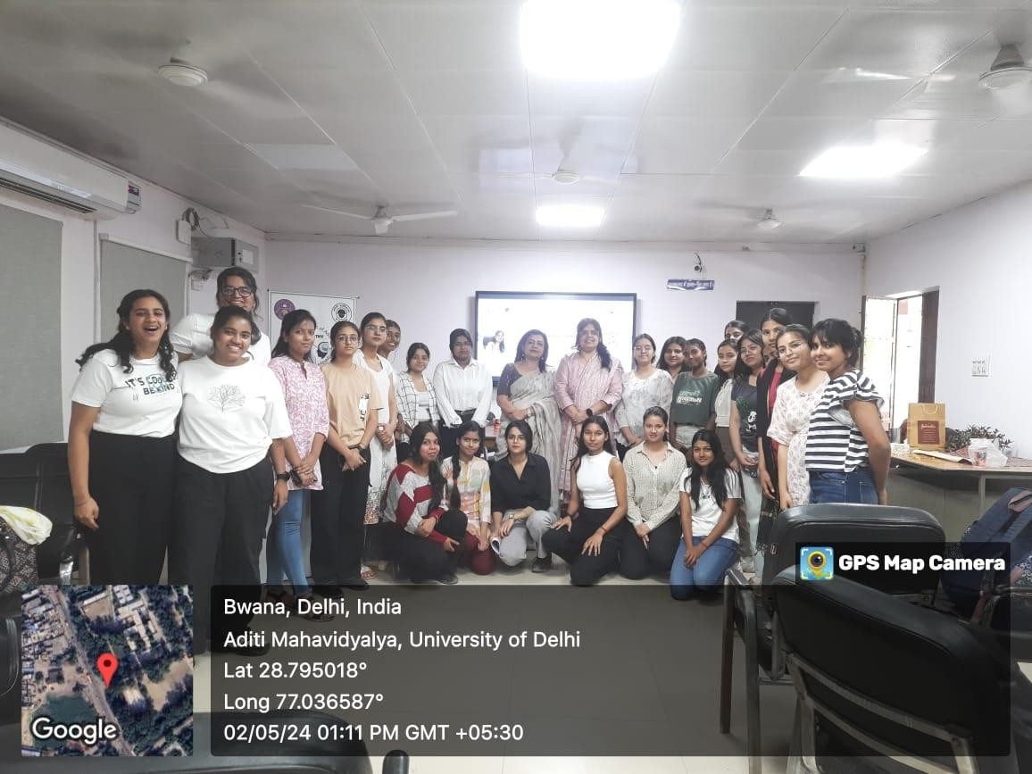
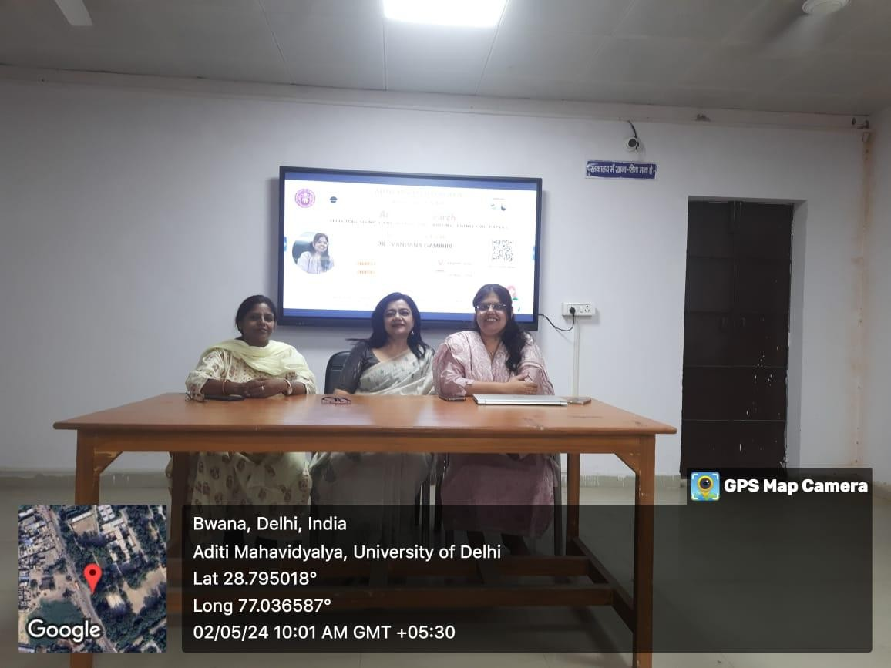

Email address | Name | Year
sakshijha394@gmail.com | Sakshi Jha | 3rd Year
chotuyadav0905@gmail.com | Ritu yadav | 3rd Year
sachankhushi0@gmail.com | khushi sachan | 3rd Year
urvashikaushik240@gmail.com | Urvashi | 3rd Year
dixitishika70@gmail.com | Ishika | 3rd Year
ishakanaujiya25@gmail.com | Isha Kanaujiya | 3rd Year
saxenariddhi29@gmail.com | Riddhi Saxena | 1st Year
tanisha211004@gmail.com | Tanisha giri | 1st Year
yogitachoudhary341@gmail.com | yogita | 1st Year
prachichopra343@gmail.com | Prachi Chopra | 2nd Year
sakshijha394@gmail.com | Sakshi Jha | 3rd Year
chotuyadav0905@gmail.com | Ritu yadav | 3rd Year
sachankhushi0@gmail.com | khushi sachan | 3rd Year
urvashikaushik240@gmail.com | Urvashi | 3rd Year
dixitishika70@gmail.com | Ishika | 3rd Year
ishakanaujiya25@gmail.com | Isha Kanaujiya | 3rd Year
saxenariddhi29@gmail.com | Riddhi Saxena | 1st Year
tanisha211004@gmail.com | Tanisha giri | 1st Year
yogitachoudhary341@gmail.com | yogita | 1st Year
prachichopra343@gmail.com | Prachi Chopra | 2nd Year
nyasha.050323@gmail.com | Nyasha | 1st Year
vanshi.sharma27112004@gmail.com | Vanshika sharma | 1st Year
charvikhurana13@gmail.com | Charvi Khurana | 1st Year
sakshisharma1504september@gmail.com | Sakshi Sharma | 2nd Year
anubhavtripathi441@gmail.com | Shelly | 1st Year
Riyabajaj2211@gmail.com | Riya Bajaj | 2nd Year
choudharyvandana720@gmail.com | Vandana | 1st Year
saxenashivi21189@gmail.com | Bhumi saxena | 1st Year
gaurkashish46@gmail.com | Kashish Gaur | 1st Year
kajaljangra529@gmail.com | Kajal | 2nd Year
ujalakatariya7@gmail.com | Roshni | 3rd Year
rishikasahoo2003@gmail.com | Rishika sahoo | 2nd Year
mahipriya0003@gmail.com | Mahi Priya | 2nd Year
kaurtanpreet32@gmail.com | Tanpreet kaur | 2nd Year
nitu.singh7524@gmail.com | Riya singh | 1st Year
singhvaishnavi0248@gmail.com | Vaishnavi | 1st Year
kritikakhandor@gmail.com | Kritika | 1st Year
baghelruby667@gmail.com | Ruby kumari | 2nd Year
neetupanchal2666@gmail.com | Neetu panchal | 2nd Year
shubhisharma9837@gmail.com | Shubhi sharma | 2nd Year
kehkashashaikh21@gmail.com | Kehkasha bano | 1st Year
priyankabidla96@gmail.com | Priyanka | 1st Year
aakirtipandey81@gmail.com | Aakriti Pandey | 1st Year
ishikakumari4237@gmail.com | Ishika kumari | 3rd Year
singaredivya9@gmail.com | Divya singare | 1st Year
diyavyas636@gmail.com | Diya vyas | 1st Year
snehagupta9944@gmail.com | Sneha Gupta | 2nd Year

2. Name of the event- Scope & Career in Psychology
Department /committee– Empathy- Psychology Association
Date – 22nd April,2024
EMPATHY, the Psychological Association of Aditi Mahavidyalaya organised a special event on the topic SCOPE AND CAREERS IN THE FIELD OF PSYCHOLOGY with Dr Aakanksha Bhatia, a renowned career counsellor and founder of Manrahi.
The event was held in two sessions, the first session discussed about the various scopes in the field of psychology and the upcoming and new diverse fields of psychology were conferred.
The second session highlighted the career prospects in the field. Various other disciplines of psychology along with their outlooks in career development was discussed as well.
Various offbeat and traditional career trajectories were explored and talked about providing a deeper understanding and insight in the field.
The event was concluded on a positive note with students grateful for the opportunity to connect over the shared passion of psychology
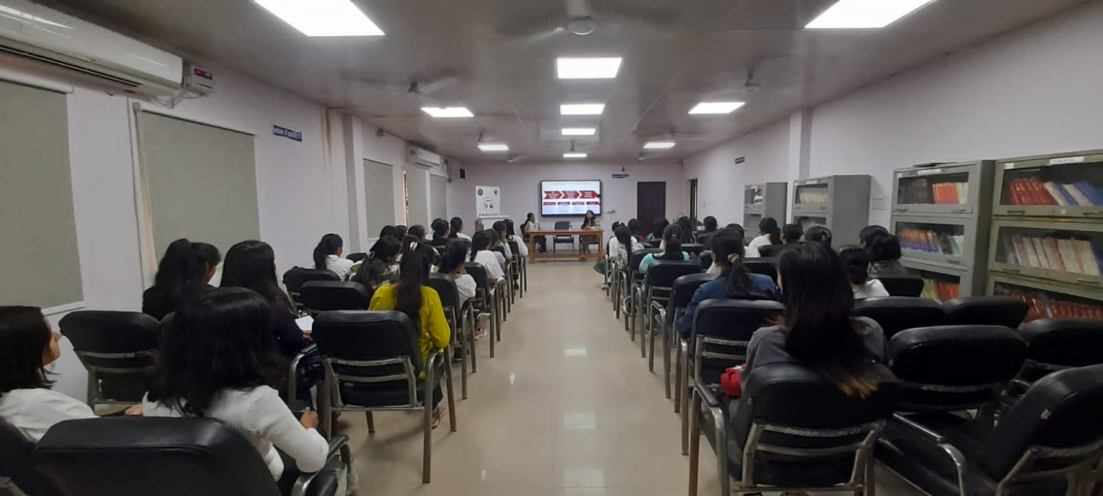
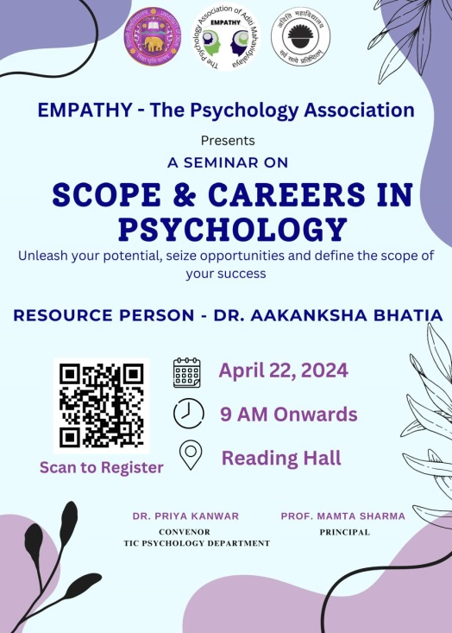

Email address | Name | Year
shreyansichauhan11@gmail.com | shreyanshi Chauhan | 3rd Year
rehnumakhatoon0786@gmail.com | Rehnuma khatoon | 3rd Year
aasthamathpal@gmail.com | Aastha Mathpal | 3rd Year
tannu011999@gmail.com | Niti paliwal | 3rd Year
salonishakya2009@gmail.com | Shivani Shakya | 3rd Year
nazukgupta017@gmail.com | Nazuk Gupta | 2nd Year
Kirtigarg4546@gmail.com | Kirti | 3rd Year
hk6836249@gmail.com | Heena | 3rd Year
alisha72898055@gmail.com | Alisha khan | 3rd Year
nupurtawar0@gmail.com | Nupur Tawar | 3rd Year
sakshijha394@gmail.com | Sakshi Jha | 3rd Year
chotuyadav0905@gmail.com | Ritu yadav | 3rd Year
sachankhushi0@gmail.com | khushi sachan | 3rd Year
urvashikaushik240@gmail.com | Urvashi | 3rd Year
dixitishika70@gmail.com | Ishika | 3rd Year
ishakanaujiya25@gmail.com | Isha Kanaujiya | 3rd Year
saxenariddhi29@gmail.com | Riddhi Saxena | 1st Year
tanisha211004@gmail.com | Tanisha giri | 1st Year
yogitachoudhary341@gmail.com | Yogita | 1st Year
prachichopra343@gmail.com | Prachi Chopra | 2nd Year
nyasha.050323@gmail.com | Nyasha | 1st Year
vanshi.sharma27112004@gmail.com | Vanshika sharma | 1st Year
charvikhurana13@gmail.com | Charvi Khurana | 1st Year
sakshisharma1504september@gmail.com | Sakshi Sharma | 2nd Year
anubhavtripathi441@gmail.com | Shelly | 1st Year
Riyabajaj2211@gmail.com | Riya Bajaj | 2nd Year
choudharyvandana720@gmail.com | Vandana | 1st Year
saxenashivi21189@gmail.com | Bhumi saxena | 1st Year
gaurkashish46@gmail.com | Kashish Gaur | 1st Year
kajaljangra529@gmail.com | Kajal | 2nd Year
ujalakatariya7@gmail.com | Roshni | 3rd Year
rishikasahoo2003@gmail.com | Rishika sahoo | 2nd Year
mahipriya0003@gmail.com | Mahi Priya | 2nd Year
kaurtanpreet32@gmail.com | Tanpreet kaur | 2nd Year
nitu.singh7524@gmail.com | Riya singh | 1st Year
singhvaishnavi0248@gmail.com | Vaishnavi | 1st Year
yashodakhandelwal04@gmail.com | Yashoda Khandelwal | 1st Year
komal006singh@gmail.com | Komal Singh | 3rd Year
tyagimanvi106@gmail.com | Manvi Tyagi | 1st Year
pixiesirius1806@gmail.com | Aishwarya Panigrahi | 1st Year
memansa896@gmail.com | Memansa | 1st Year
charurana182@gmail.com | KUMARI CHARU RANA | 1st Year
sansrakriti@gmail.com | SANSKRITI SINGH | 2nd Year
ananyawadhwa03@gmail.com | Ananya wadhwa | 3rd Year
aditirana0019@gmail.com | Aditi Rana | 1st Year
anilyadav77343@gmail.com | Archana | 1st Year
kashishkohar19@gmail.com | Kashish | 1st Year
megharojha025@gmail.com | Megha | 2nd Year
1607radhika@gmail.com | Radhika | 2nd Year
griddhi61@gmail.com | Riddhi gupta | 1st Year
ishiqabansal16@gmail.com | Ishiqa Bansal | 1st Year
archanaraikwar26@gmail.com | Dimple Raikwar | 2nd Year
neetapandey112@gmail.com | Neeta Pandey | 1st Year
riyagolaop@gmail.com | Riya | 1st Year
umad07870@gmail.com | Khushboo sindhura | 2nd Year
uditajain47@gmail.com | Udita Jain | 2nd Year
kumaripreeti807667@gmail.com | Preeti Kumari | 2nd Year
ritikasangwan14@gmail.com | Ritika | 1st Year
priyanshigoswami1506@gmail.com | Priyanshi Goswami | 1st Year
commercejuhi@gmail.com | Juhi | 2nd Year
vaishnavimishra1630@gmail.com | Vaishanavi Kumari | 2nd Year
dhadoliya02@gmail.com | Shobha | 1st Year
shivangiji30@gmail.com | Shivangi | 1st Year
monikayadav1853@gmail.com | Monika | 2nd Year
nisha.kanojia70115@gmail.com | Nisha kanojia | 3rd Year
931055419.ms@gmail.com | Monika Sharma | 1st Year
chavilaata@gmail.com | Chavi | 1st Year
malarani01121985@gmail.com | Palak jadaun | 1st Year
nj23773@gmail.com | Naina jaiswal | 1st Year
sharmatamanna656@gmail.com | Tamanna Sharma | 1st Year
shikharajput9399@gmail.com | Deepshikha | 1st Year
kumarisadhna510@gmail.com | Kumari Sadhna | 1st Year
mgs2neha@gmail.com | Neha Sharma | 1st Year
rashijoshi8126@gmail.com | Rashi Joshi | 1st Year
shagunrajshree@gmail.com | SHAGUN RAJSHREE | 1st Year
Shwetasingh98110@gmail.com | Shweta singh | 1st Year
bhumikaaaa.12@gmail.com | Bhumika | 1st Year
khushitripathi459@gmail.com | Khushi tripathi | 1st Year
kritikakhandor@gmail.com | Kritika | 1st Year
baghelruby667@gmail.com | Ruby kumari | 2nd Year
neetupanchal2666@gmail.com | Neetu panchal | 2nd Year
shubhisharma9837@gmail.com | Shubhi sharma | 2nd Year
kehkashashaikh21@gmail.com | Kehkasha bano | 1st Year
priyankabidla96@gmail.com | Priyanka | 1st Year
aakirtipandey81@gmail.com | Aakriti Pandey | 1st Year
ishikakumari4237@gmail.com | Ishika kumari | 3rd Year
singaredivya9@gmail.com | Divya singare | 1st Year
diyavyas636@gmail.com | Diya vyas | 1st Year
snehagupta9944@gmail.com | Sneha Gupta | 2nd Year
sandhya.kumari110106@gmail.com | Sandhya kumari | 1st Year
singh.akansha9975@gmail.com | Akansha | 1st Year
karishmadixit44@gmail.com | Karishma Dixit | 3rd Year
afsafaisal2003@gmail.com | Afsa | 2nd Year
umangyadav3005@gmail.com | Umang Yadav | 1st Year
sourabhaditi2024@gmail.com | Aditi | 1st Year
komalpal82948@gmail.com | Komal | 2nd Year
harshita270805@gmail.com | Harshita | 1st Year
tanvithakran11@gmail.com | Tanvi thakran | 1st Year
chiya241203@gmail.com | Bhumika bhagat | 2nd Year
ayushichaudhary129@gmail.com | Ayushi Chaudhary | 1st Year
nanshijangra16@gmail.com | Nanshi | 1st Year
khushipunjaban05@gmail.com | Khushi wadhwa | 2nd Year
aashisishodia.2005@gmail.com | Aashi | 1st Year
dahiyababli951@gmail.com | Arzoo | 3rd Year
radhakumari5374@gmail.com | Radha | 1st Year
hemusingh2004@gmail.com | Hemlata | 3rd Year
nikkixnini.2912@gmail.com | Nikki | 1st Year
Snehajha573@gmail.com | Sneha | 2nd Year
ns4794710@gmail.com | Neha | 1st Year
imyashikaarora@gmail.com | Yashika | 2nd Year
fareensaifi925@gmail.com | Fareen | 1st Year
anjali876333304@gmail.com | Anjali | 2nd Year
khushboosingh639791@gmail.com | Khushboo | 2nd Year
gargiraghav2005@gmail.com | Gargi Raghav | 2nd Year
suhani9910@gmail.com | Suhani | 2nd Year
veditatuteja@gmail.com | Vedita | 1st Year
shraddhadwivedi.0561@gmail.com | Shraddha dwivedi | 1st Year
gauranshigupta544@gmail.com | Gauranshi Gupta | 1st Year
sakshipahuja132004@gmail.com | Sakshi pahuja | 2nd Year
phimanshi217@gmail.com | Himanshi | 2nd Year
sehgalbhuvi@gmail.com | Bhuvi sehgal | 3rd Year
shriwastavanjali7@gmail.com | Anjali | 1st Year
samridhigupta865@gmail.com | Samridhi gupta | 1st Year
shrutibansal9112002@gmail.com | Shruti Bansal | 2nd Year
himanshideepa@gmail.com | Himanshi gautam | 1st Year
bhumisharma5683@gmail.com | Bhumi sharma | 1st Year
gaurm7531@gmail.com | Muskan gaur | 1st Year
niveditamaharaj1914@gmail.com | Nivedita Maharaj | 2nd Year
m49475205@gmail.com | Aditi Singh | 1st Year
rajkhushbu36@gmail.com | Khushbu raj | 1st Year
ekusaxena121@gmail.com | Ekta Saxena | 2nd Year
khyatisingh1122@gmail.com | Khyati Singh | 2nd Year
dikshamaan91@gmail.com | Diksha Maan | 2nd Year
ananya05205@gmail.com | Ananya | 1st Year
aparnakori143@gmail.com | Aparna | 1st Year
devrohilla507@gmail.com | Mehak | 1st Year
snehagupta032004@gmail.com | Sneha | 3rd Year
ns87002526@gmail.com | Nisha | 1st Year
itsrishitachaudhary15@gmail.com | Rishita Dagar | 1st Year
m97389155@gmail.com | Muskan raj | 1st Year
jainsomya367@gmail.com | Somya jain | 1st Year
dulcie.s005@gmail.com | Dulcie | 1st Year
anjaligupta33388@gmail.com | Anjali Gupta | 1st Year
sumankumari993950@gmail.com | Suman | 1st Year
riyarajberkap26118@gmail.com | Riya Raj | 1st Year

3. Name of the event- LEVARGING LINKEDIN
Department /committee– Empathy- Psychology Association
Date – 23rd April,2024
EMPATHY, the association of Department of Psychology on 23rd April, 2024 in collaboration Prof. Varda Sardana organized an informative seminar on LinkedIn namely LEVERAGING LINKEDIN. The event was conducted in collaboration with the Jaipuria Institute of Management.
The event was held in two sessions. The first session began with creating a deeper understanding about LinkedIn as a necessary and professional platform for students. Prof Varda highlighted the need for students to create a proper profile with main focus on showcasing the unique skills each student possesses.
In the second half of the session, the spotlight was shifted to learning how a student can produce a creative and engaging post on LinkedIn such as posting their daily life which may become a source of motivation for some and others may see correlation between their situations.
The learning outcomes were comprehensive, from creating a compelling profile that highlights one’s expertise to using relevant content to connect with experts and fellow students all over the world.

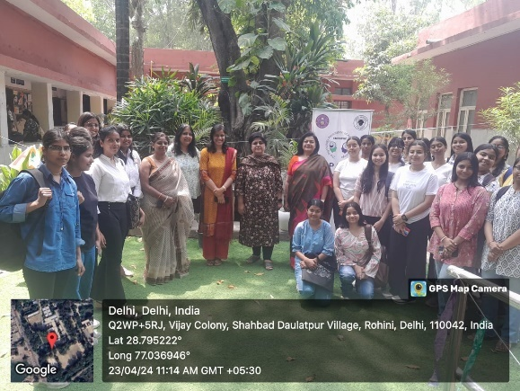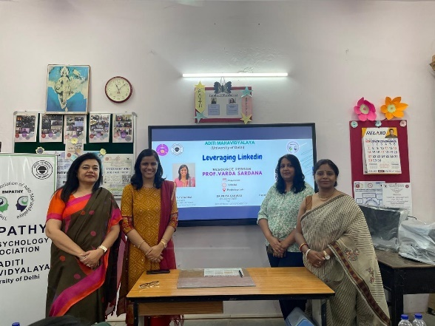
Email address | Name | Year
nehasharma19210@gmail.com | Neha sharma | 1st Year
shreyasingh75894@gmail.com | Shreya | 1st Year
kashishkohar19@gmail.com | kashish | 1st Year
kirtigarg4546@gmail.com | Kirti | 3rd Year
sonikadrall3103@gmail.com | Sonika Drall | 3rd Year
sampurnaguha28@gmail.com | Sampurna Guha | 3rd Year
tamannas3413@gmail.com | Tamanna | 3rd Year
karishmadixit44@gmail.com | Karishma Dixit | 3rd Year
rashmimahoriya@gmail.com | Rashmi | 3rd Year
ishakanaujiya25@gmail.com | Isha Kanaujiya | 3rd Year
anushkasri8888@gmail.com | Anushka Srivastava | 3rd Year
aasthamathpal@gmail.com | Aastha Mathpal | 3rd Year
1607radhika@gmail.com | Radhika | 2nd Year
monisajain2004@gmail.com | Monisa | 2nd Year
aaru639318@gmail.com | Archana kumari | 1st Year
drishtyy31@gmail.com | Drishti | 1st Year
ishasisodiya843@gmail.com | Isha Sisodiya | 2nd Year
tanziagangar.02@gmail.com | Tanzia | 1st Year
rashikatyagi04@gmail.com | Rashika | 1st Year
lodhidivya38@gmail.com | Divya Lodhi | 1st Year
kbhavna396@gmail.com | Bhavna Kumari | 1st Year
roshnidp27@gmail.com | Roshni | 2nd year
Kirtigarg4546@gmail.com | Kirti | 3rd year
anushkanegi133@gmail.com | Anushka | 3rd year
tamannas3413@gmail.com | Tamana | 3rd year
8587828147k@gmail.com | Khushi | 3rd year
hk6836249@gmail.com | Hena | 3rd year

4. Name of the event- Roadmap for Civil Services Examination Preparation
Department /committee– Extensive Lecture series committee
Date - April 26, 2024
Expert- Kautilya gyanmanjiri IAS academy
Extensive Lecture series committee, Aditi Mahavidyalaya organised an interactive session on" Roadmap for Civil Services Examination Preparation," in collaboration with kautilya gyanmanjiri IAS academy. Attendees were treated to a vibrant interaction session led by Mr. Vinay Kumar Jindal, Additional District Magistrate of West Delhi. The session commenced at 11:00 AM on April 26, 2024, at the college auditorium.
The organizing committee, comprising Dr. Santosh Yadav, Dr. Manish Vats, Dr. Sunita Dhaiya, Prof. Pooja Khanna, Prof. Neetu Rana,Dr. Lovely ensured the seamless execution of the event. Professor Dr. Mamta Sharma, principal , Aditi Mahavidyalaya provided invaluable support and guidance throughout.Participants, including students and enthusiasts alike, benefited greatly from the expertise shared during the session, gaining a clearer understanding of the preparation process for one of India's most prestigious examinations. Around 97 students participated in the event.
During the event, Mr. Vinay Kumar Jindal, with his extensive experience as Additional District Magistrate of West Delhi, shared invaluable insights into the nuances of preparing for the Civil Services Examination. He highlighted the importance of comprehensive preparation, emphasizing the need for a well-structured study plan that covers all aspects of the examination syllabus.Mr. Jindal delved into the significance of time management, stressing the need for candidates to allocate sufficient time to each section while balancing revision and practice. He provided practical strategies for optimizing study schedules and making the most of available resources, including recommended books, online platforms, and coaching institutes.
Moreover, he shed light on the significance of current affairs and general awareness in the examination, offering tips on staying updated with relevant news and events. He emphasized the importance of critical thinking and analytical skills, encouraging participants to develop a holistic understanding of socio-economic and political issues.
Furthermore, speaker shared personal anecdotes and success stories, inspiring attendees with tales of perseverance and dedication. He emphasized the importance of maintaining a positive mindset and resilience in the face of challenges, urging candidates to stay motivated throughout their preparation journey.
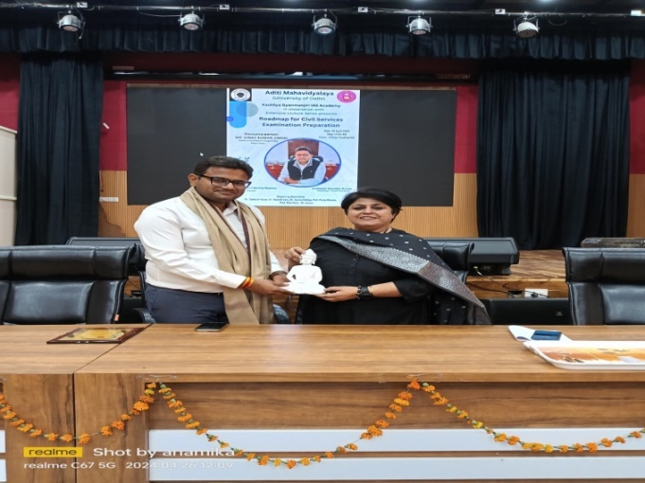
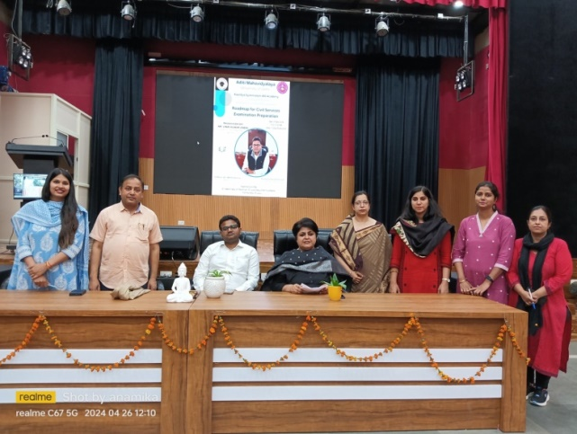
Overall, participants gained valuable insights into effective study strategies, time management techniques, and the essential qualities needed to succeed in the Civil Services Examination, making the event both informative and inspirational.
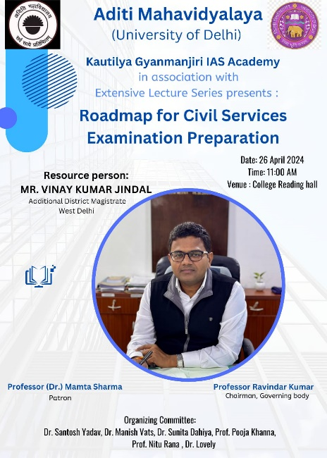

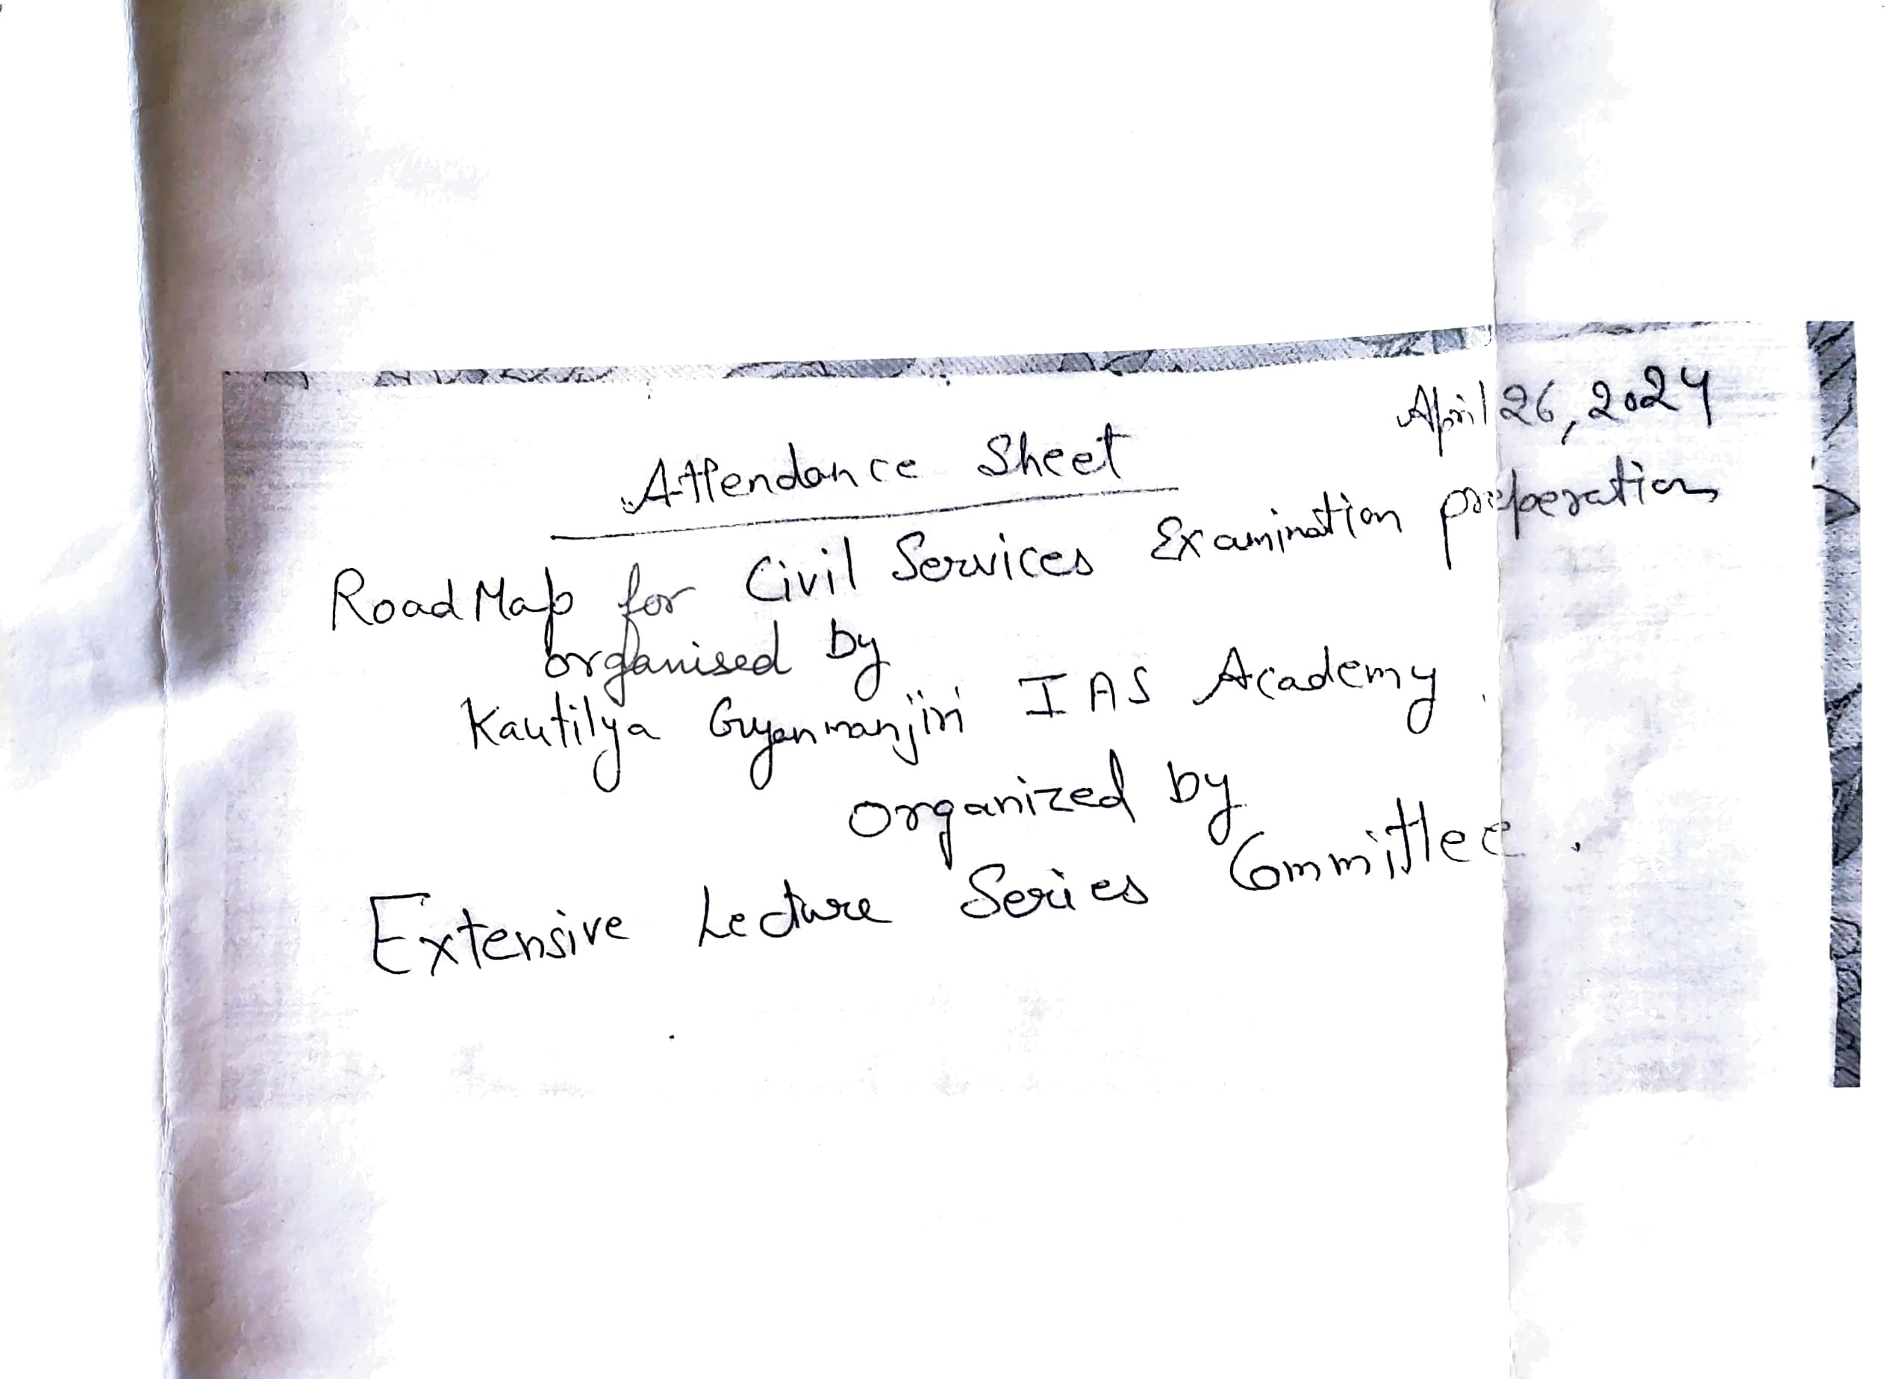

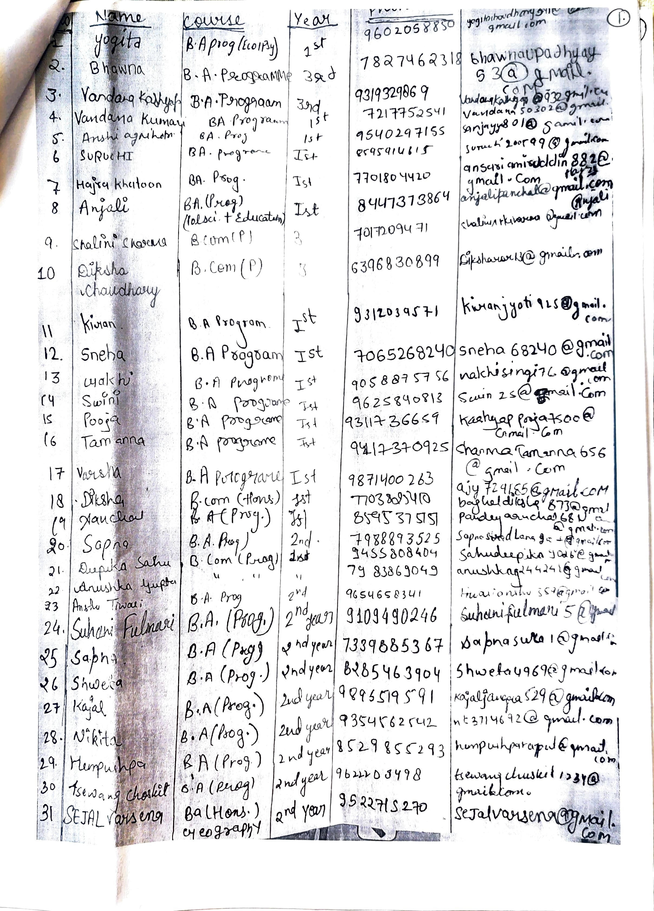

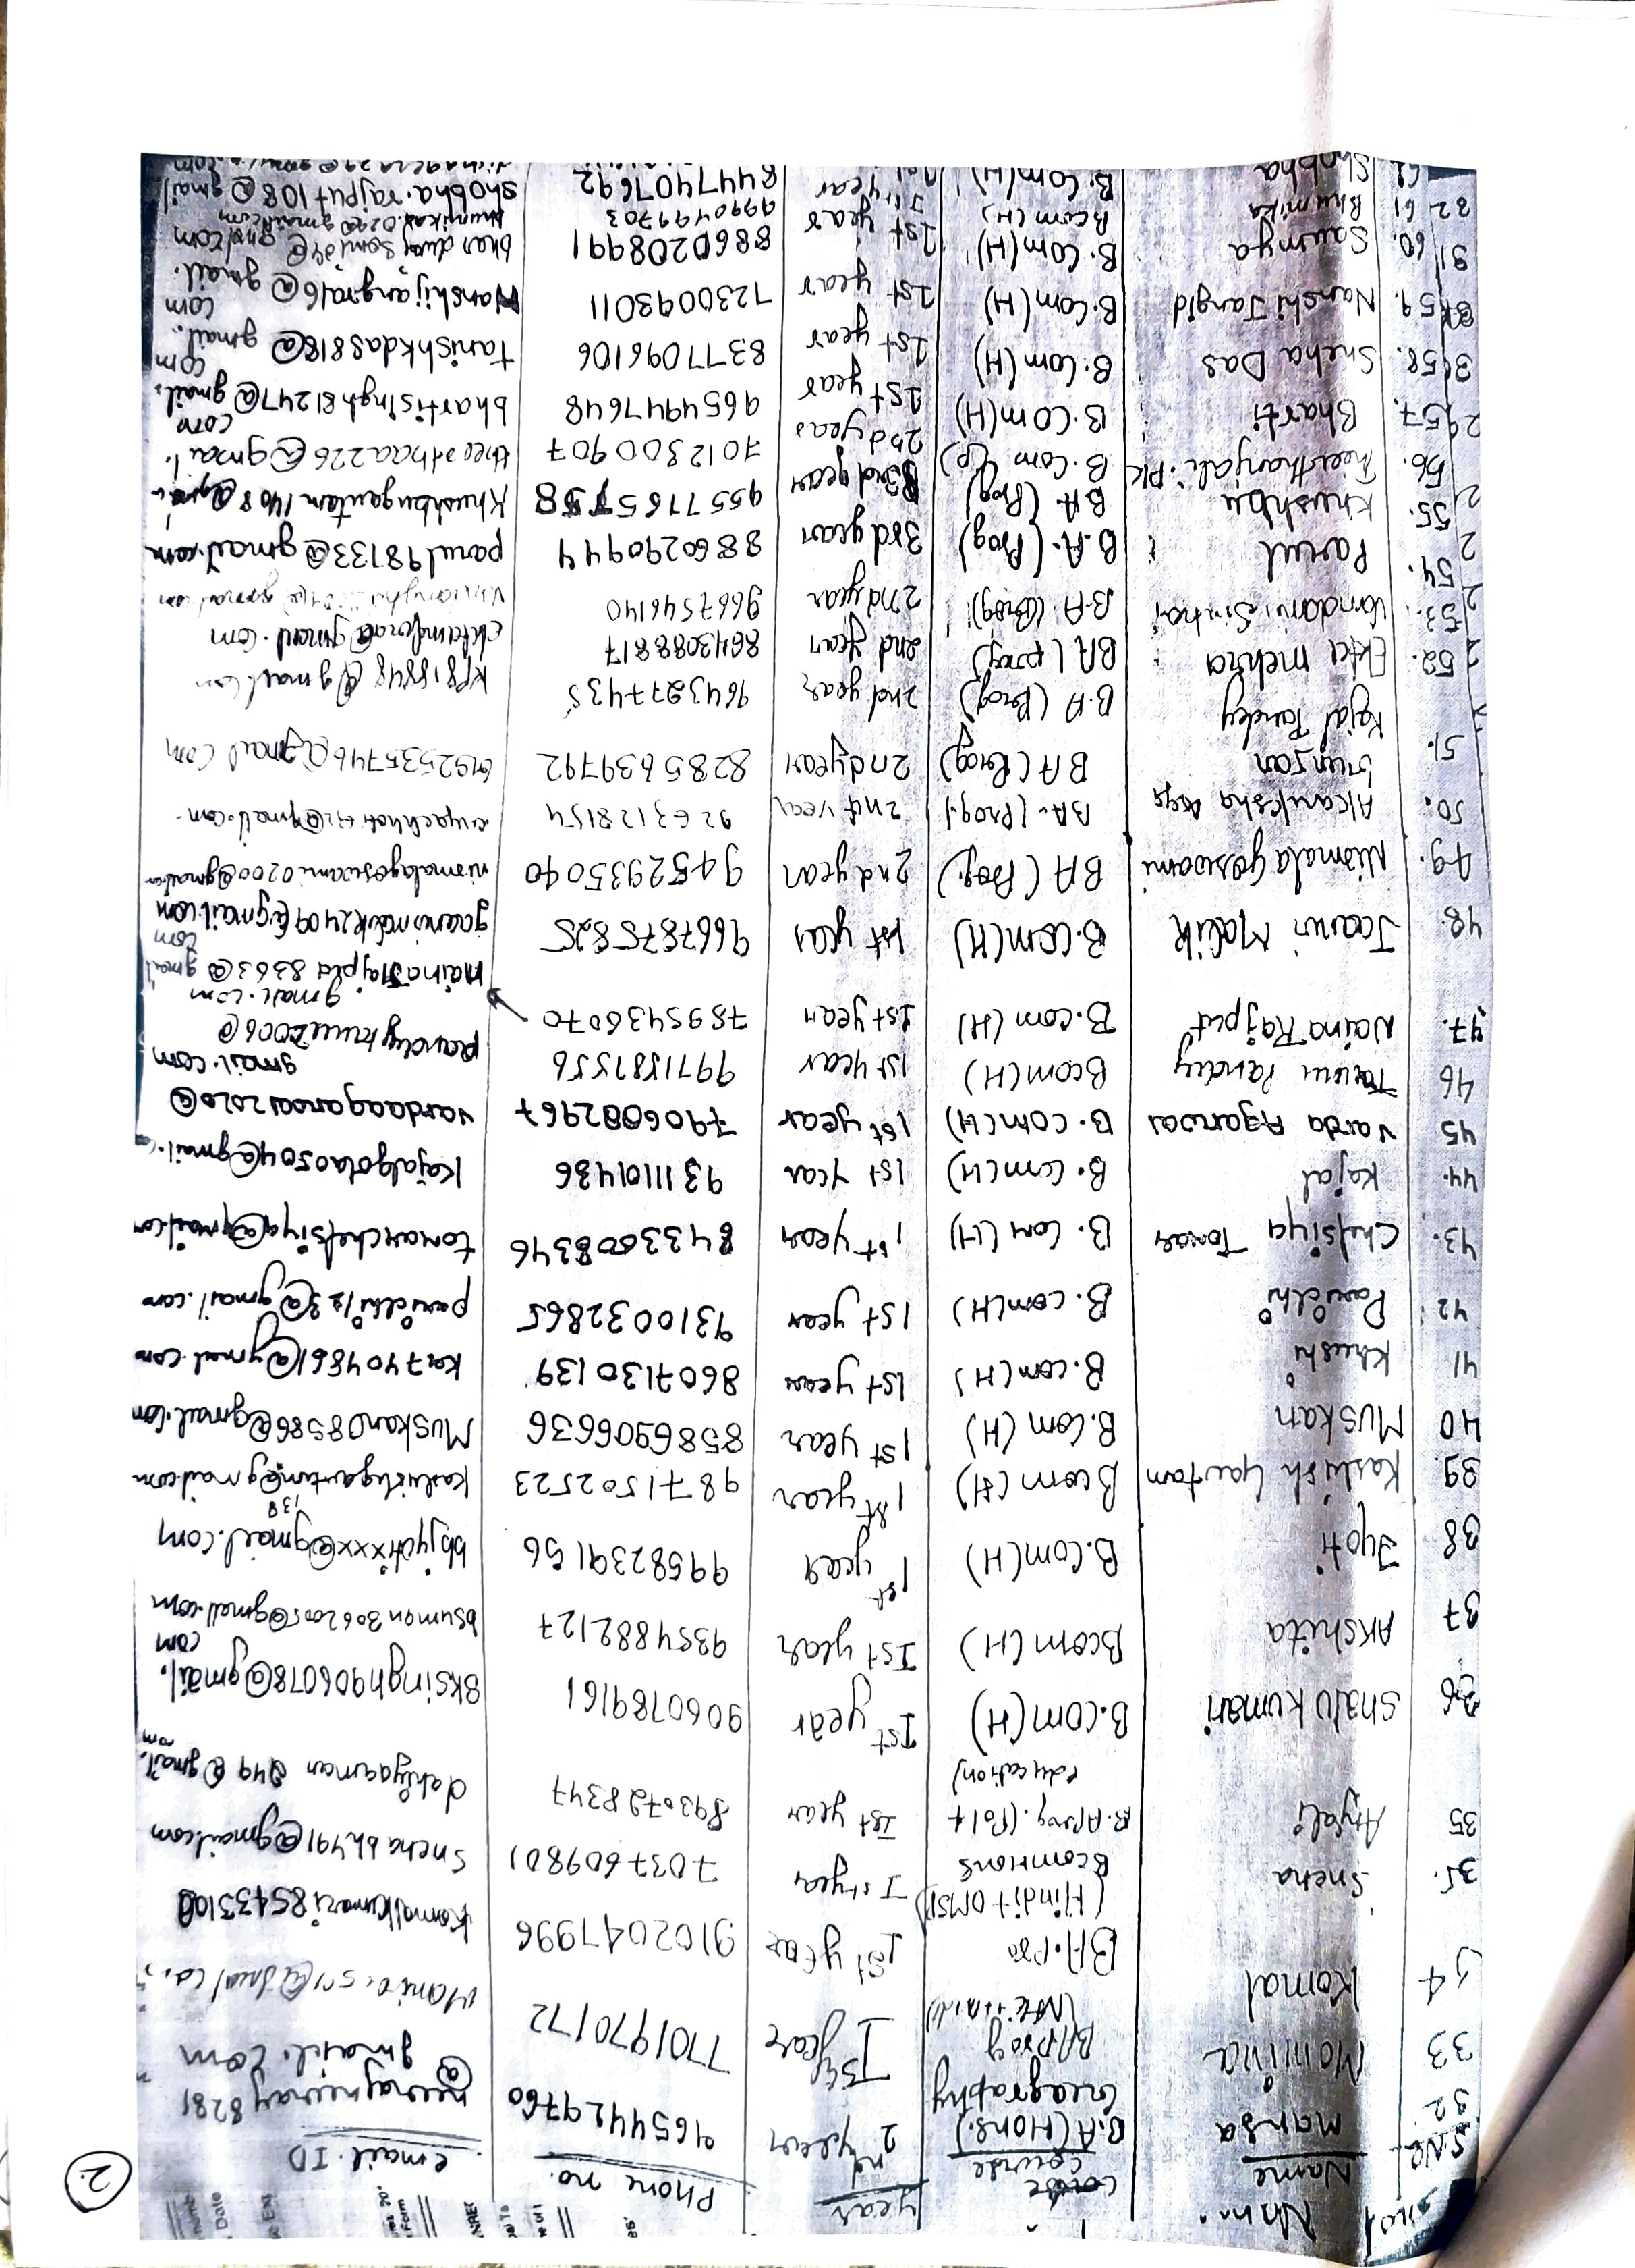

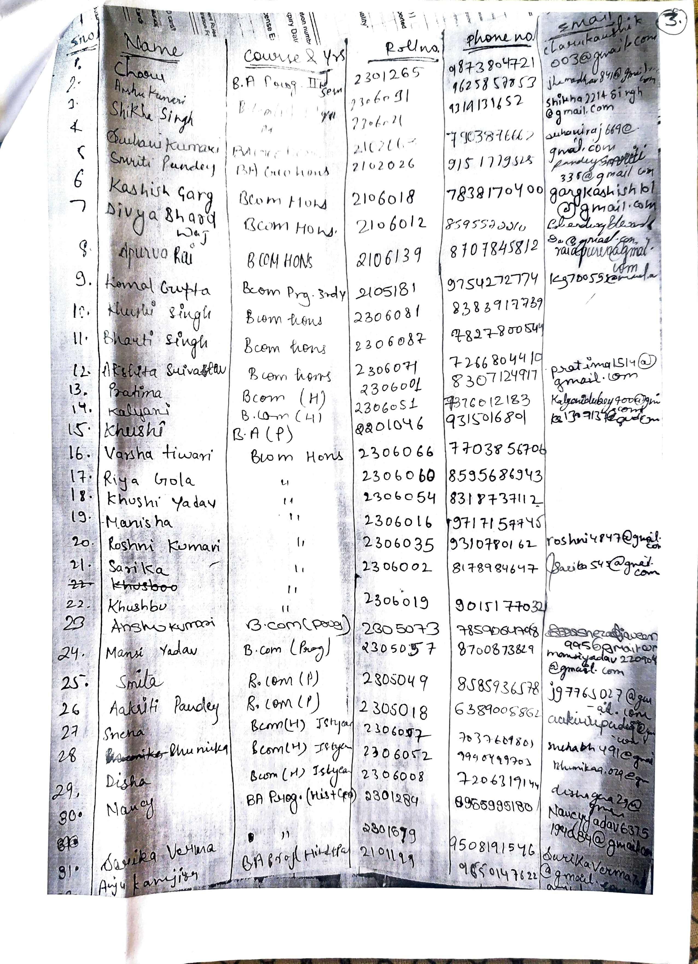

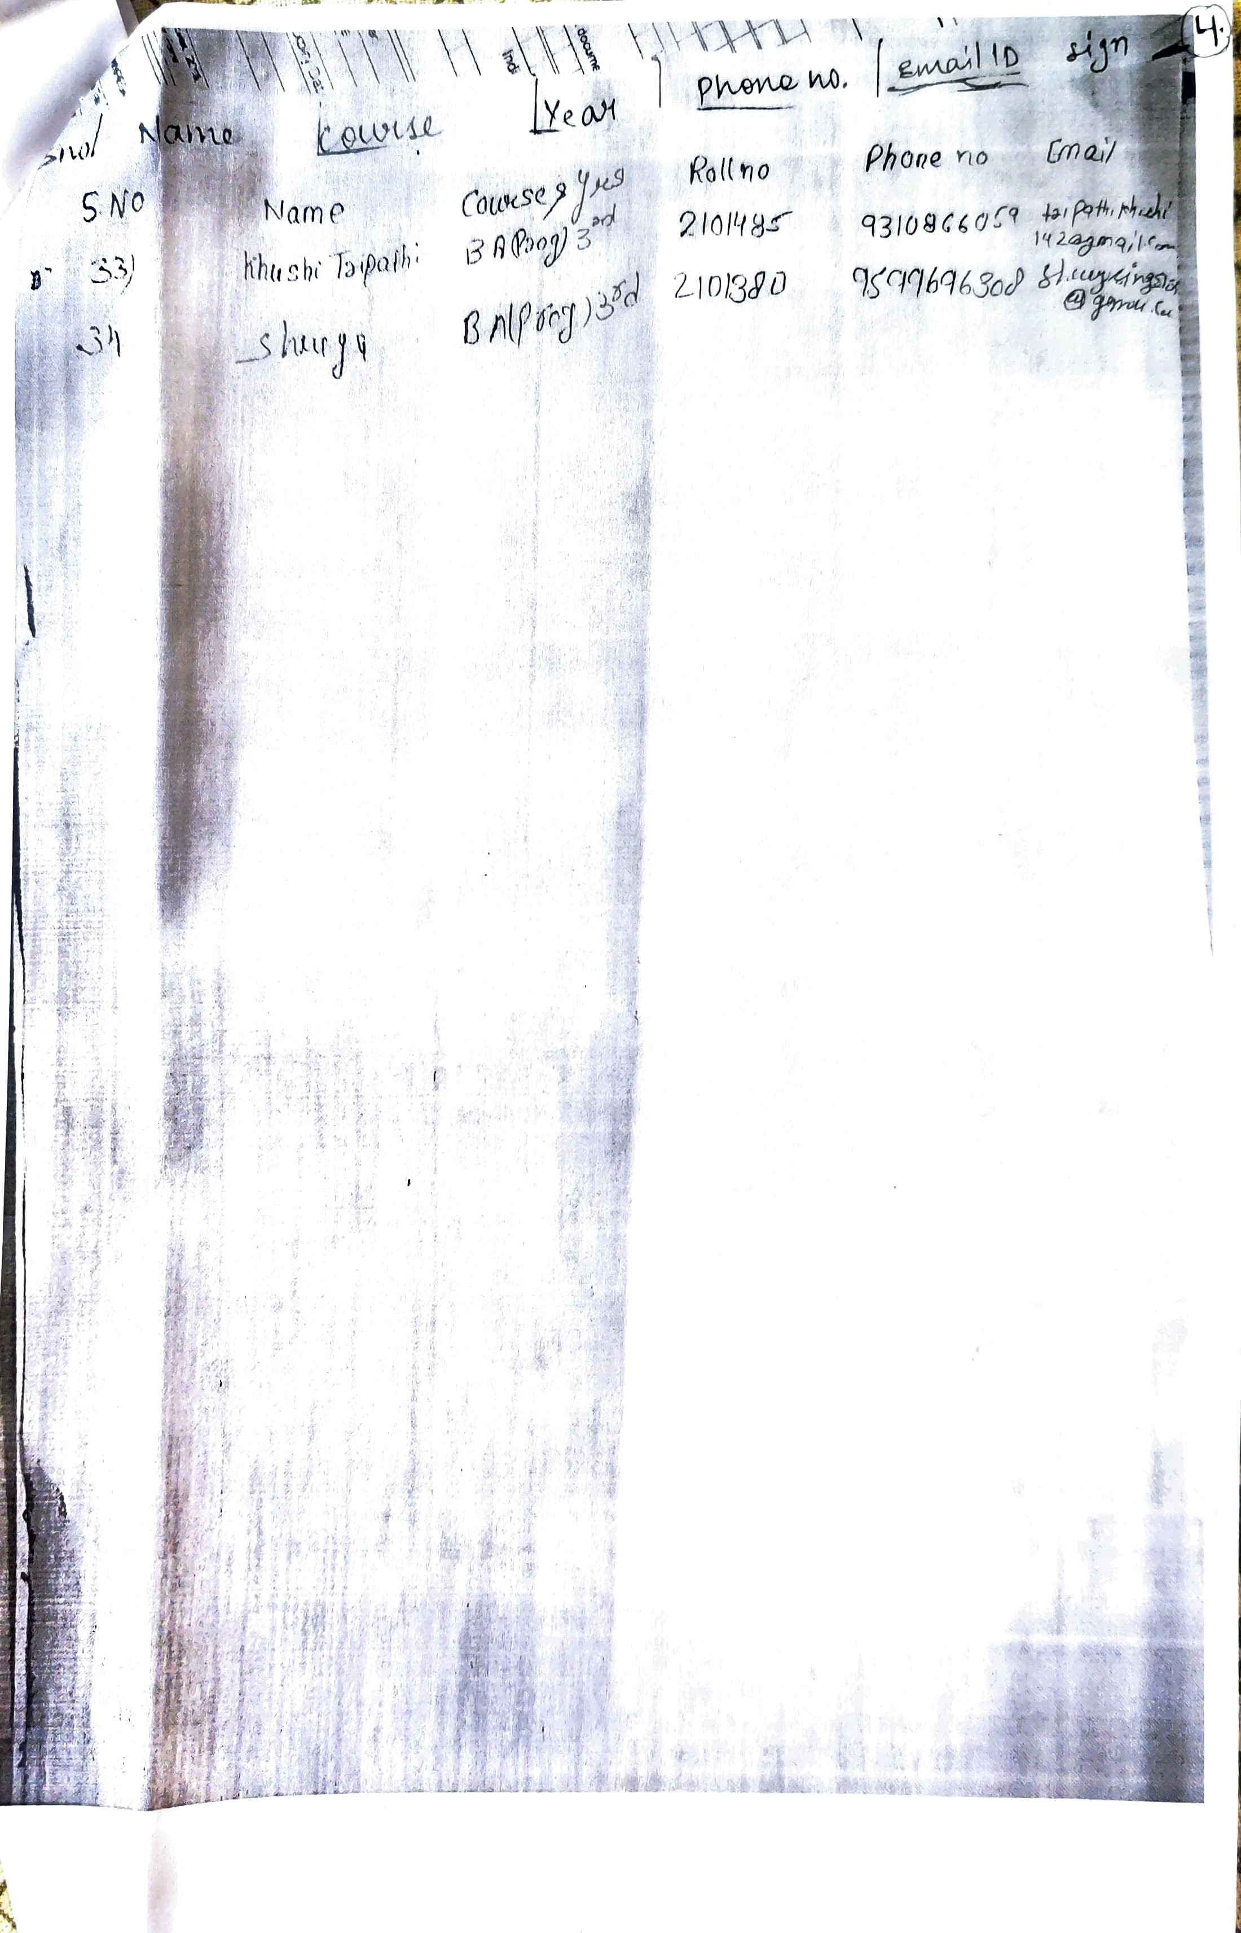

5. Name of the event- Career Guidance session
Department /committee– Department of social work
Date - 21/3/2024
Expert- Mr. Ram Chauhan (Head- Silver line Foundation)
Career Guidance session was organized on 21/3/2024 by the department of social work. The objective to explore and familiarize with various academic aspects of different universities. Prof. Beena Antony Reji (Field Work Coordinaror) welcomed the both the resource persons. Mr. Ram Chauhan introduced himself and his prominent organization named Silver line Foundation which has it’s head office at Dwarka, Delhi. He introduced his vision and the target population of the organization that is the Children and Women. He gave us information about many of the projects run by the organization.
Mr. Akhand from ISRD, was also an Advocate. He works for TI and mainly focuses on HIV AIDS & Drug users. And is working in the South West Delhi region. Thirty three students were attended participated in the session.

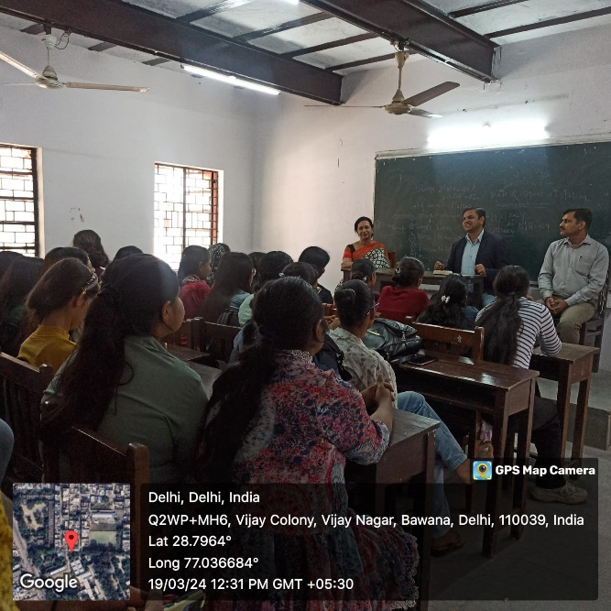

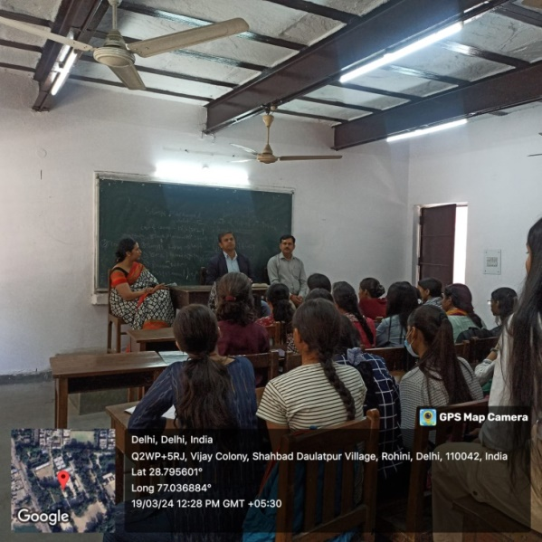

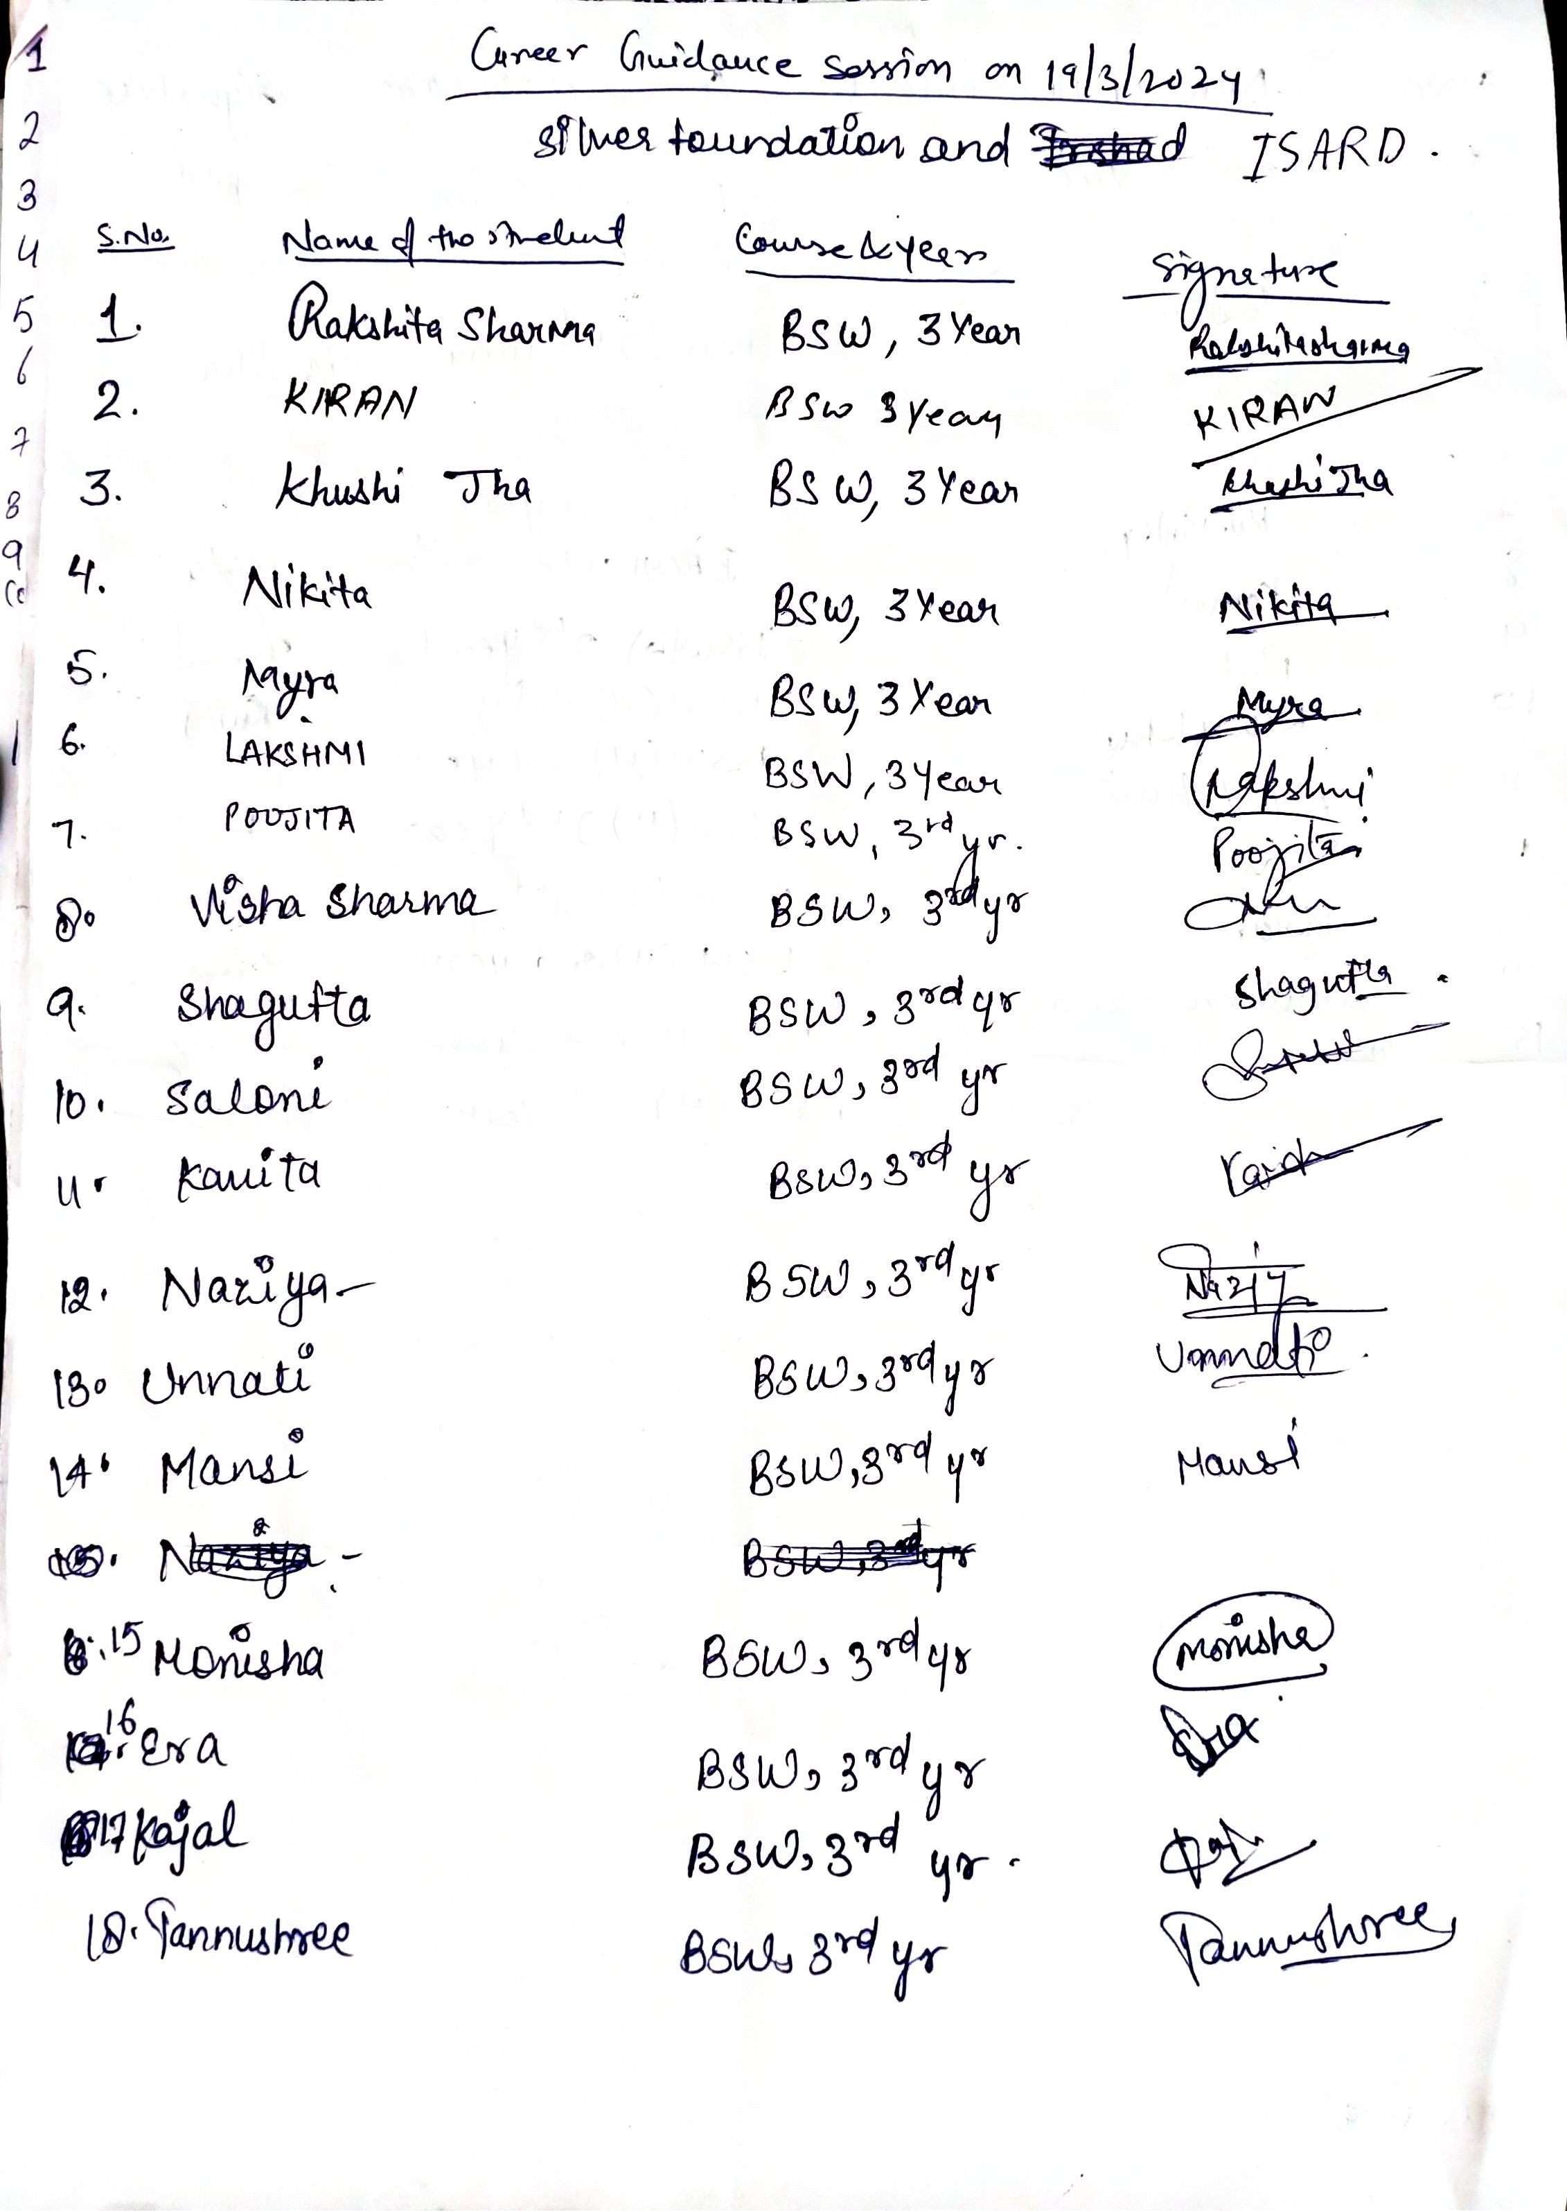
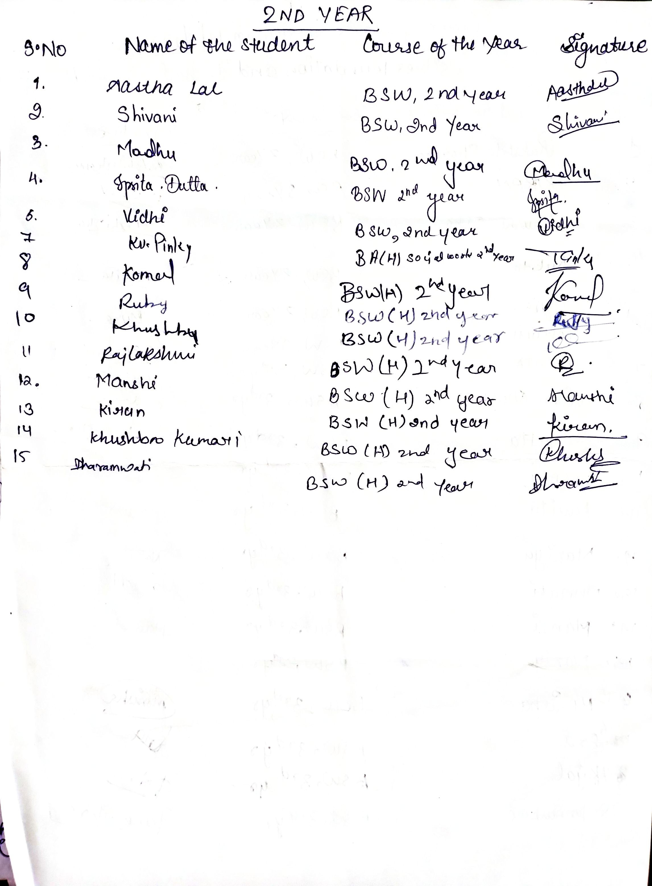

6. Name of the event- Career Guidance session
Department /committee– Dept of education
Date- May 7, 2024
A career counseling session was organised by the dept of education on May 7,2024 for the students of the BElEd programme. Faculty of BM College Sonipat, Haryana Ms Neetu and Ms Sunita , Assistant Professors interacted with students about the careers in education in general and courses offered by their college in specific.
136 students of 2nd, 3rd and 4th year attended the session and discussed their interests and queries with the invited speakers.
Session focussed upon the changing scenarios in teacher education programme and employment opportunities in teaching.
As most of the final year students prepare for the post graduation in education MEd and MA, speakers talked about MEd programme in their institution. They discussed the eligibility criteria and selection process and when and how they can apply in their university. What specific openings students get after MEd and how they can think of pursuing higher education to seek job opportunities in university system.

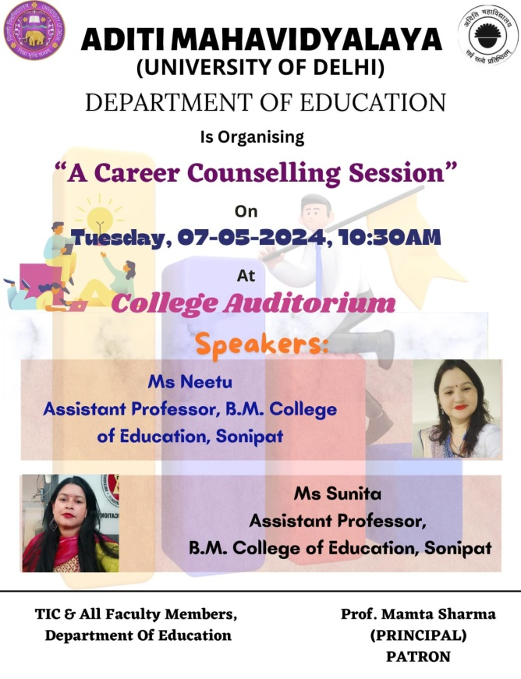

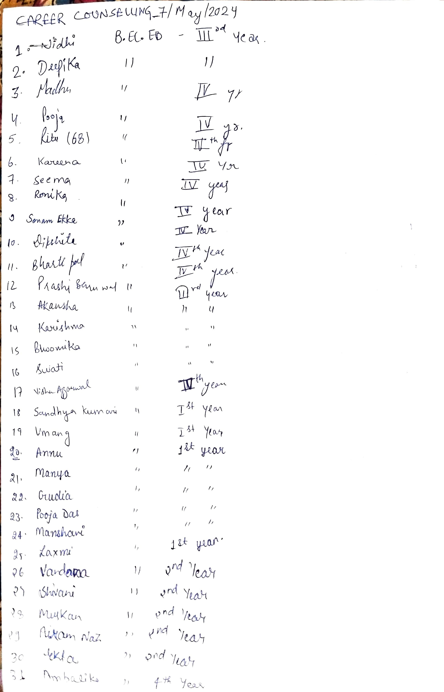
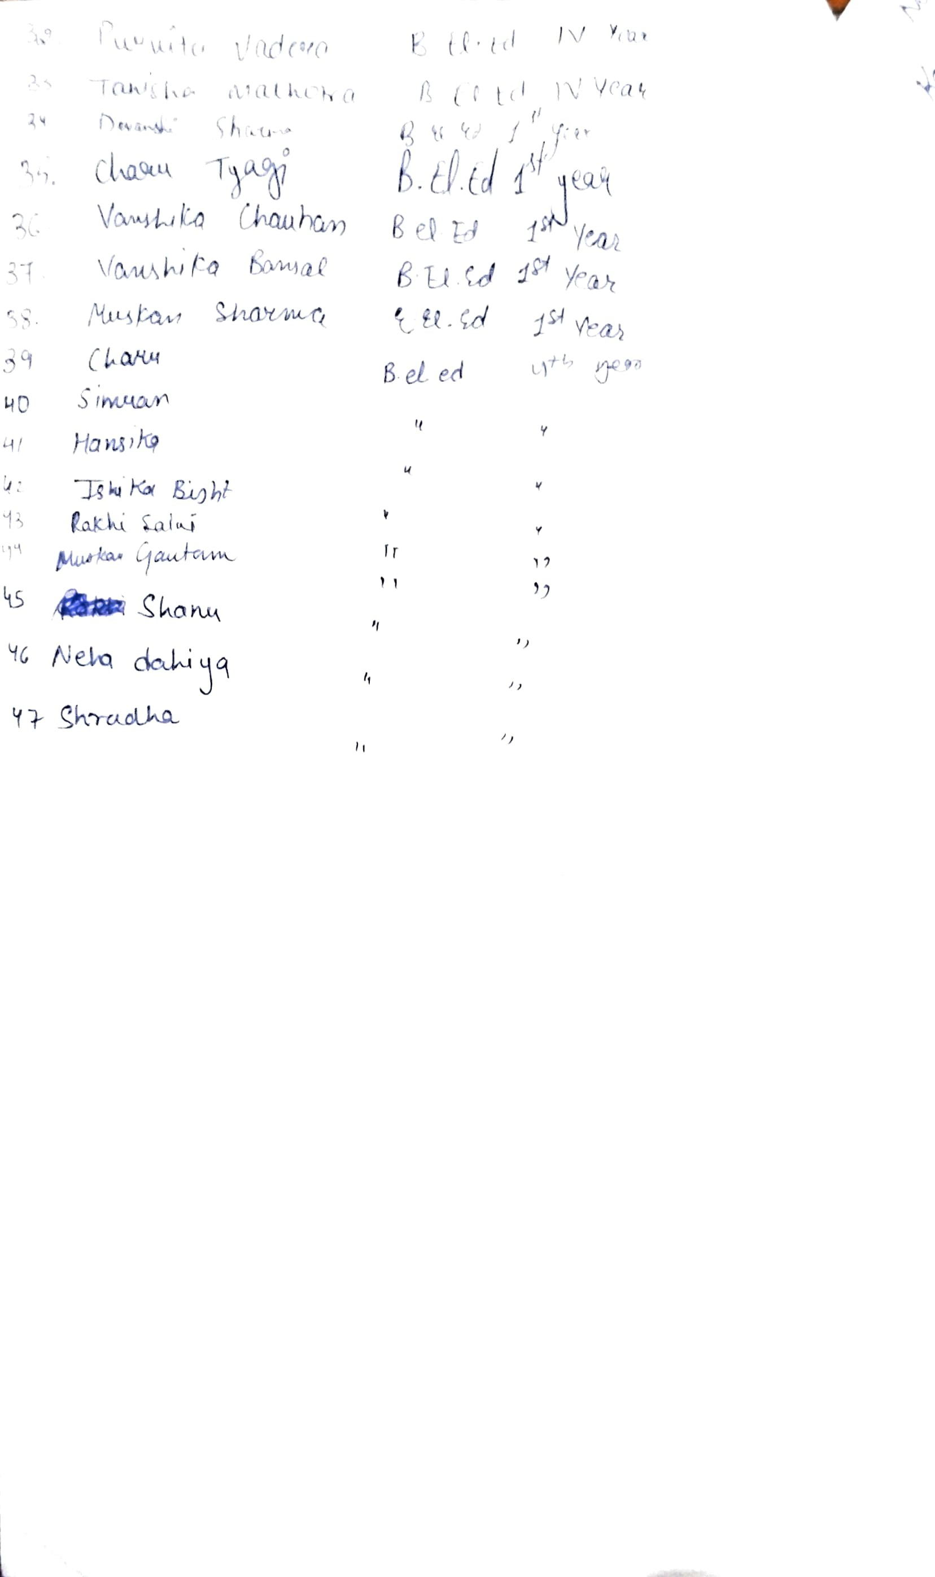

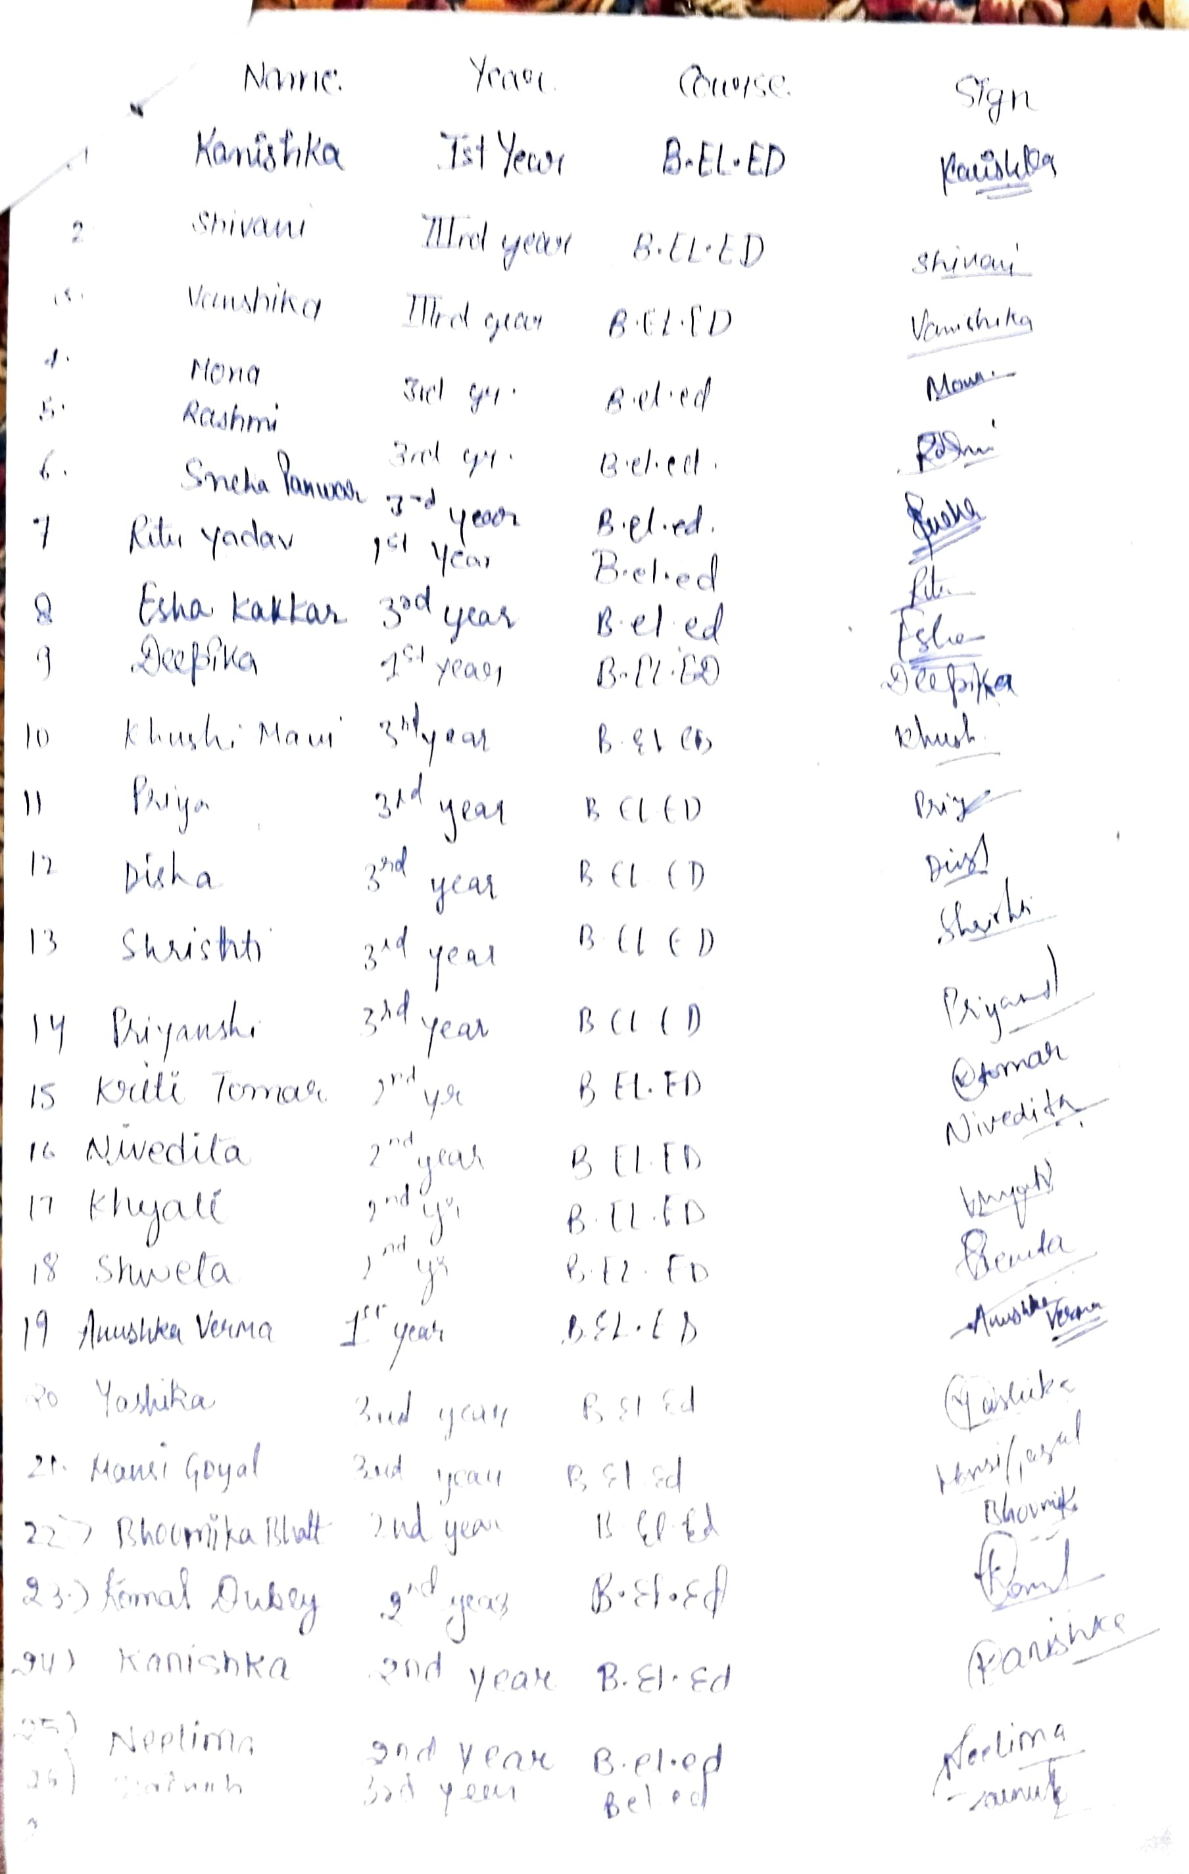

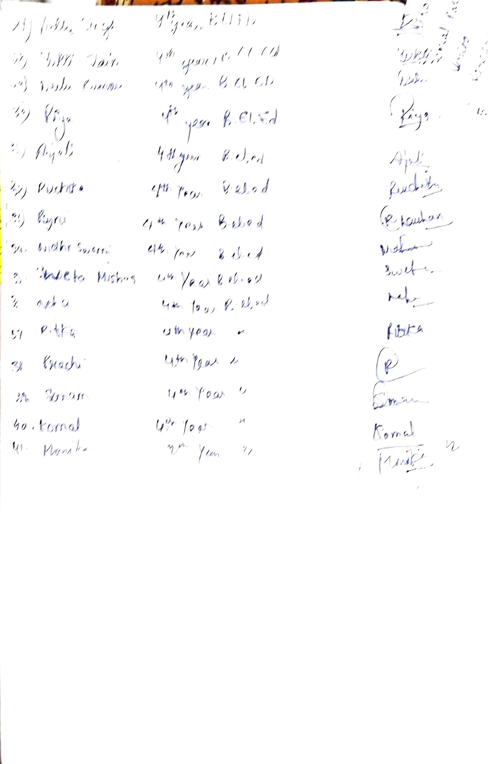

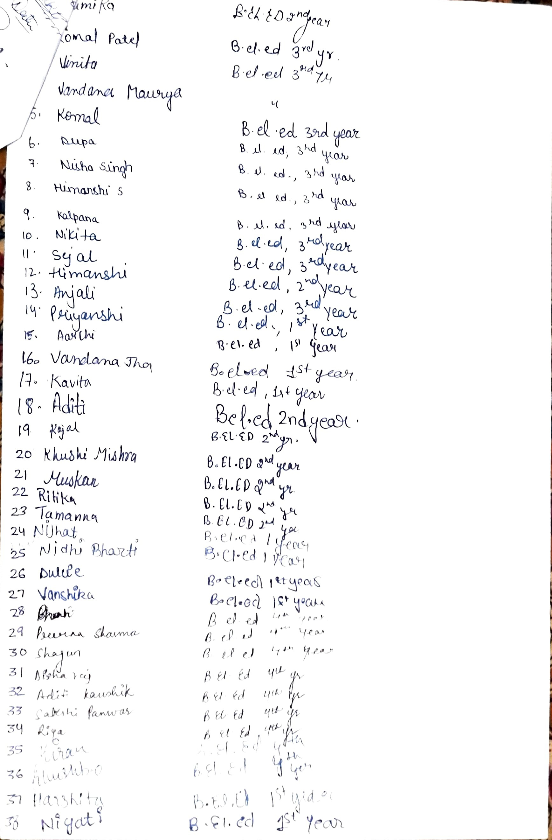

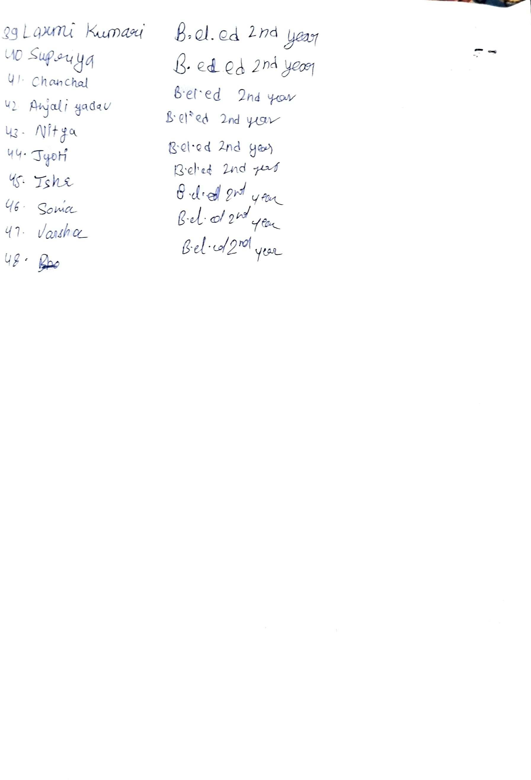

7. Name of the programme:- Career Counselling for CA
Date:- 2/9/2024
Resource persons:- Department of Commerce
Department :- Mr. Ankit Bansal, Department of Commerce

A seminar on "Career Counselling for CA" was organised on 9th February,2024 in College Auditorium. The session was conducted under the guidance of INPC Convenor Prof. Priya Kanwar and TIC prof. Hema Gupta of commerce association. The chief speaker was CA Ankit Bansal. The seminar was set in motion at 11:30 AM. CA Ankit Bansal give motivation by telling real life incidence. To attempt entrance for exam. He cleared a lot of myths. The seminar was interactive, and students learned and gained new knowledge and gave learning various tips to ace entrance. Overall, the seminar was a success, with 70+ students and it embarked thorough knowledge to the students.

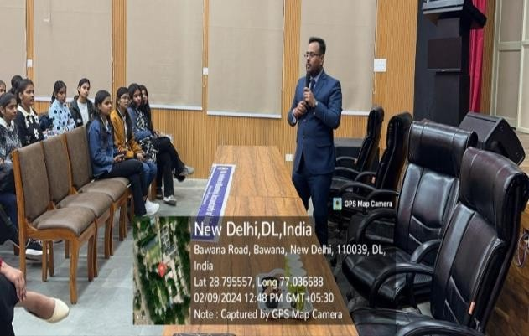
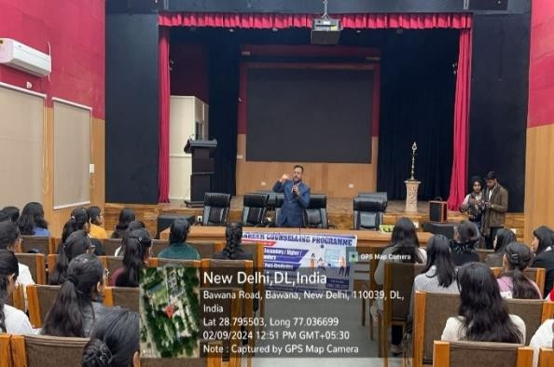
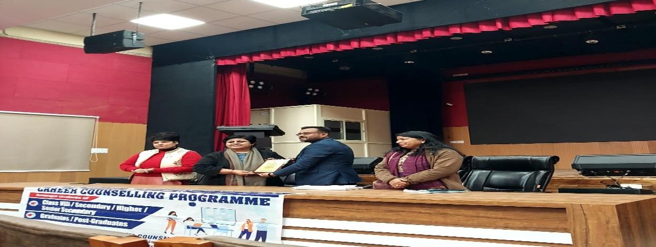
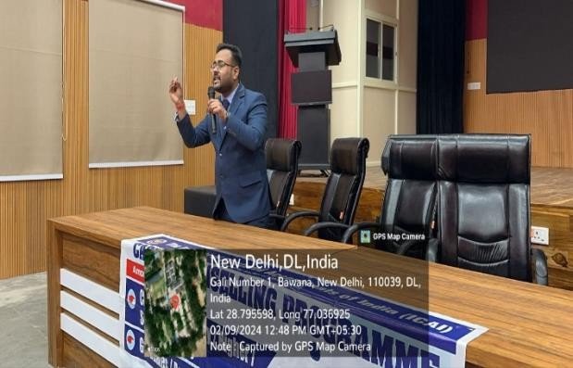
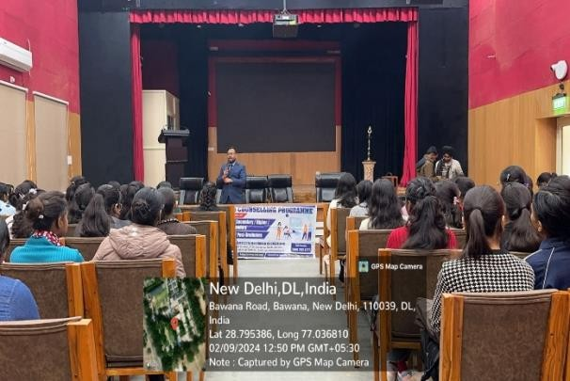

List of Participant
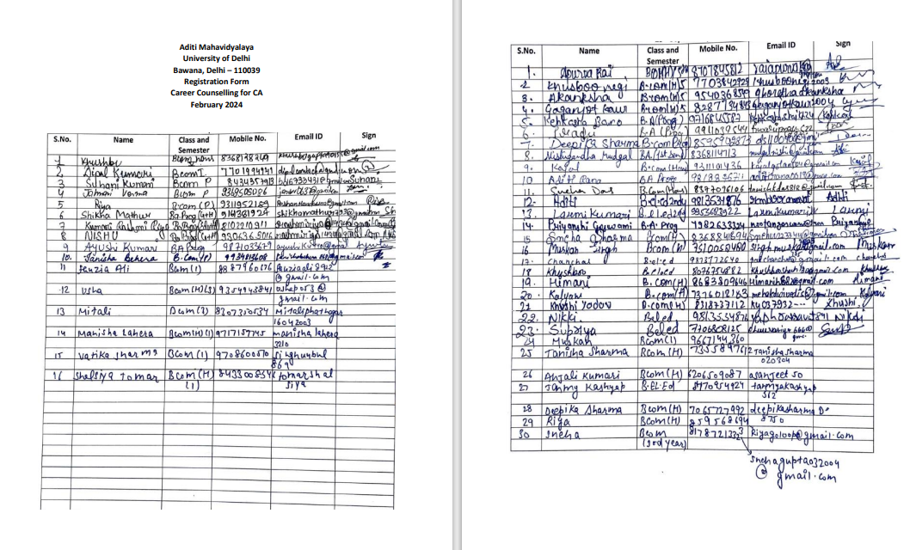

8. Name of the programme:- Career opportunities in Geo-Informatics
Date:- 2/12/2023
Resource persons:- Mr. Ravindra Tiwari (Head of Dept- Geo-Informatics) and Ms. Devashri Talukar (Faculty, NIGMT)
Department :- Department of Geography & Netra Institute of Geo-informatics
The Department of Geography organized a workshop on “Career opportunities in Geo-Informatics” on 2nd December 2023 in the GIS lab of the Department of Geography for spreading awareness about career choices, Geospatial Programs and technologies in Geo-informatics among the students. This workshop was sponsored by Netra Institute of Geo-informatics on “Fundamentals of Remote Sensing”, New Delhi. Total 50 students attended the Orientation including students from other courses as well. Mr. Ravindra Tiwari (Head of Dept- Geo-Informatics) and Ms. Devashri Talukar (Faculty, NIGMT) were resource persons. Mr. Ravindra Tiwari oriented the students about ‘Career and Remote Sensing and GIS orientation ’. Mr. Devashri Talukar introduced ERDAS software to 2nd year students and students did a practical to understand software properly. The workshop was organised for B.A. (Hons) second and third-year students. The main goal of the workshop was to orient the students with respect to career in GIS & and Remote Sensing and to allow experiencing hands on practical on “ERDAS” a remote sensing software.

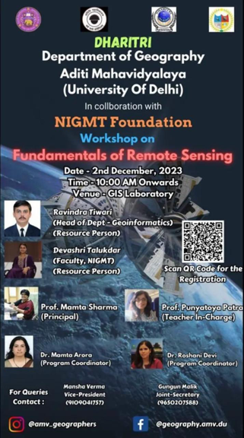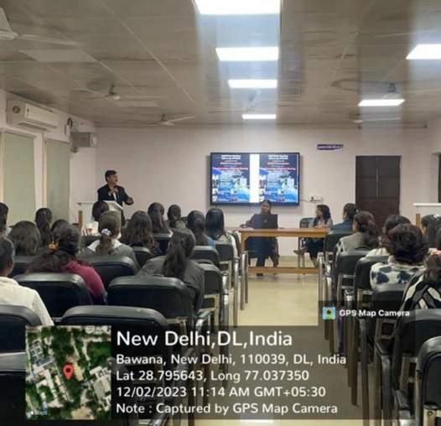

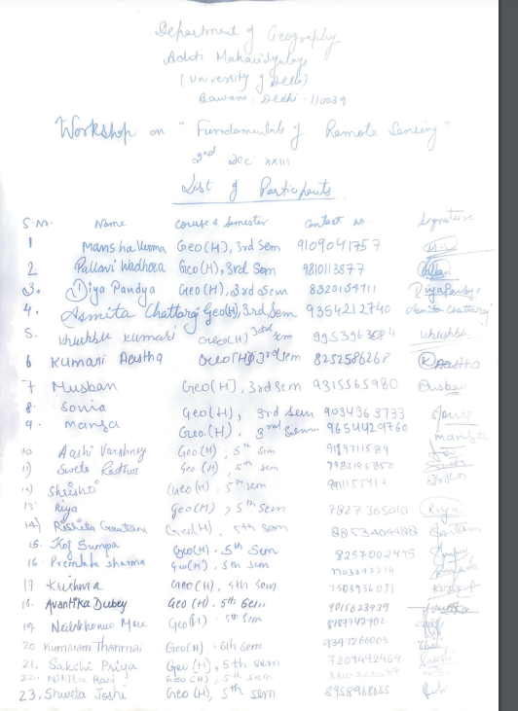
List of participants

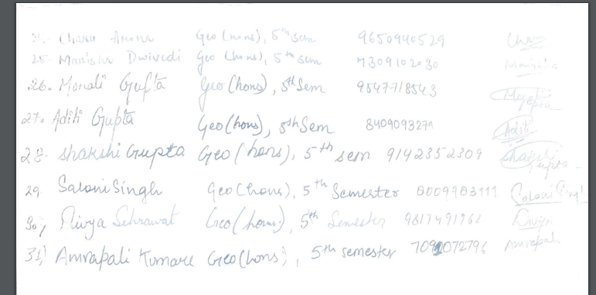

9. Name of the programme:- Webinar on Accessing Universities for Social Work as a Career: An Awareness Session
Date:- 17/4/2024
Resource persons:-
Department :- Department of Social Work
The Department of Social Work successfully hosted a webinar titled "Accessing Universities for Social Work as a Career: An Awareness Session" on Wednesday, April 17th, 2024, from 5 PM to 6 PM. Coordinated by Dr. Mali Devi Sawariya, this webinar aimed to provide valuable insights for students interested in pursuing social work as a career path. The session was inaugurated by Prof. Beena Antony Reji and was further highlighted by the presence of Dr. Rakesh Choudhary. Dr. Rahul Kapoor, Assistant Professor at Gautama Buddha University, Noida, served as the resource person. His expertise and guidance focused on the nuances of accessing universities for further studies in social work. Targeted specifically at second and third-year students pursuing B.A. (H) in Social Work, the webinar served as a vital platform for students to gain insights into university admissions and career prospects in the field. The session, hosted on Google Meet, was attended by 25 students who actively engaged with Dr. Kapoor, asking questions and discussing various aspects of social work education and careers. Through collaborative efforts and insightful discussions, the webinar significantly enhanced awareness and empowered students to make informed decisions about their academic and professional futures. Overall, the event was a valuable resource for students aspiring to advance in the field of social work, providing them with essential guidance and information to effectively navigate their educational and career pathways.

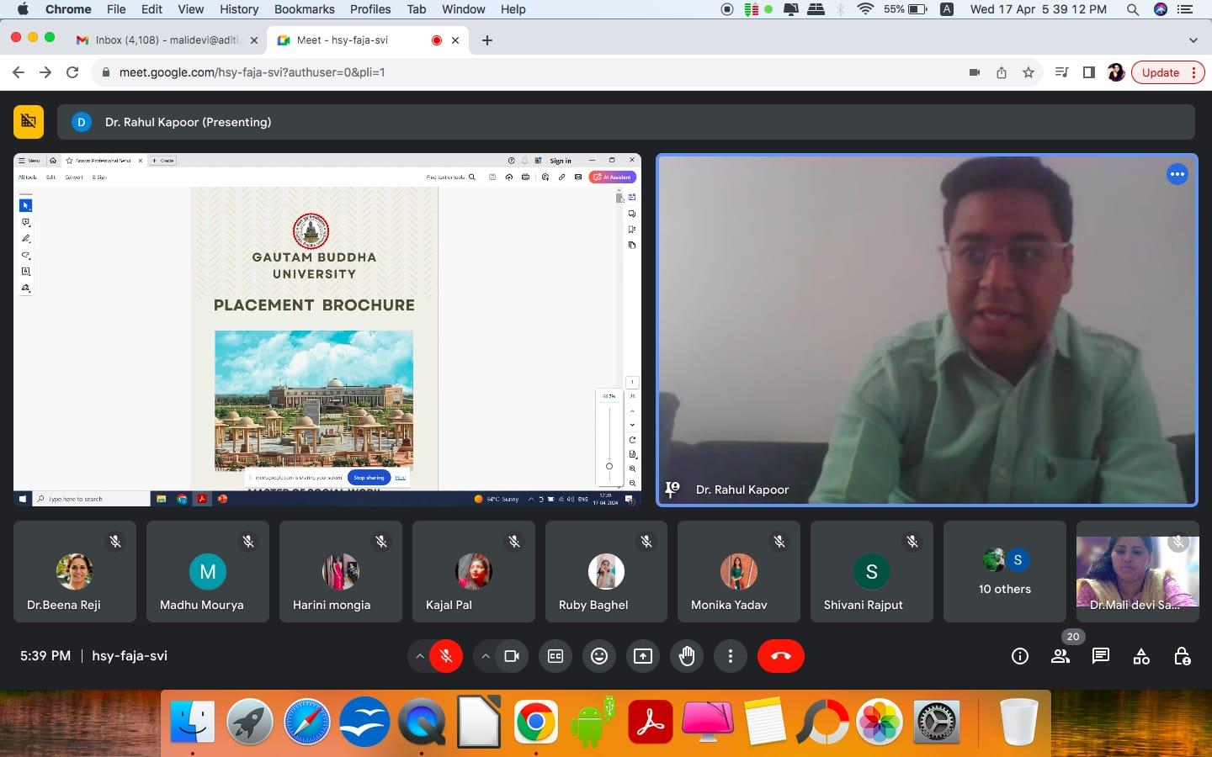

List of participants
S.No. | College Roll. No. | Name
1 | 2104002 | Khushi Jha
2 | 2104003 | Mansi Gupta
3 | 2104007 | Mona
4 | 2104008 | Saloni Yadav
5 | 2104009 | Gopika P M
6 | 2104010 | Shagufta Khaatoon
7 | 2104011 | Naziya Parveen
8 | 2104012 | Vandana
9 | 2104013 | Lakshmi
10 | 2104014 | Harini Mongia
11 | 2104015 | Maithili Jha
12 | 2104016 | Kiran
13 | 2104017 | Nancy
14 | 2104019 | Kajal Pal
15 | 2104020 | Rakshita Sharma
16 | 2104025 | Myra Sheikh
17 | 2104028 | Karishma
18 | 2104030 | Kavita Yadav
19 | 2104031 | Riya Jain
20 | 2104032 | Manisha Saini
21 | 2104033 | Ritu
22 | 2104034 | Unnati Sharma
23 | 2104039 | Monisha Nagpal
24 | 2104041 | Nikita Mishra
25 | 2104042 | Visha Sharma
26 | 2104045 | Richa Shrivastava
27 | 2104048 | Poojita Katari
28 | 2104050 | Era Era
29 | 2104052 | Kusum
30 | 2104057 | Tannushree

10. Name of the event- Union Public Services Commission
Department /committee– Internship & Placement Committee
Date – 6th October 2023
UTTHAAN - The Internship and Placement Committee of Aditi Mahavidyalaya, University of Delhi, organised a seminar on "Union Public Services Commission (UPSC)” in collaboration with FESTA MARKETING. The session was conducted under the guidance of INPC convenor Prof. Priya Kanwar. The chief speaker was Mr Viraj Rane and Ms. Shubhangi Singh faculty at GS Score. The seminar was set inmotion 10:00 AM onwards.
Ms. Mansi Sharma Student Cordinator and Ms. Vanya Sindwani Coordinator welcomed the students and the chief speakers. Ms Ramya Kathuria, Secretary or UTHAAN introduced the resource persons and invited Mr. Viraj to lead the session. The seminar aimed to provide guidance and counselling to UPSC Aspirants. More than 60 enthusiastic students participated in the session in the Reading Hall of the college.
Mr.Viraj has a great deal of experience in guiding and mentoring UPSC Aspirants. He betrothed the audience about the different aspects to keep in mind while studying for the services. He provided the students with some efficient tips on the entrance exams.
Ms. Subhangi Singh also helped provide a great insight to the students seeking their first step to prepare for the exams. She explained the importance of knowing the syllabus in order to prepare well. The seminar was interactive, and students learned and gained new knowledge about the pursuit of UPSC.
A Question and Answer session was conducted by Ms. Yuvika Nayyar, Joint Secretary of UTTHAAN. All the students eagerly participated in the session and raised their questions and cleared their doubts . Ms.Taniya Sachan, Secretary of UTTHAAN gave the vote of thanks, expressing gratitude to the speaker for sharing their knowledge and insights.
After the seminar a one-on-one counseling session was held for students who were eager to seek personalised mentorship from the resources person. Overall, this seminar was a success, as it embarked thorough knowledge to the students.
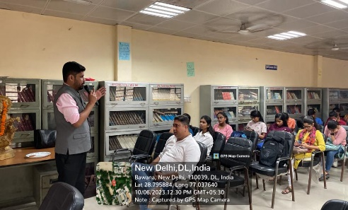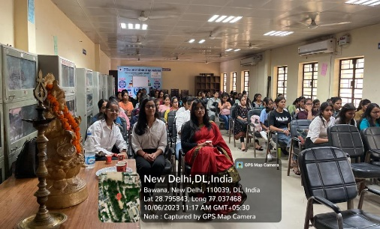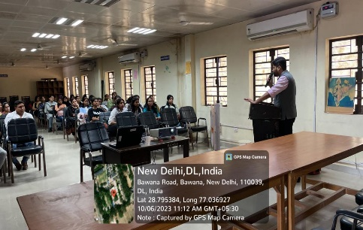
Email Address | Name | Year
taniyasachan03ts@gmail.com | Taniya Sachan | 2nd year
mansisharma22012003@gmail.com | Mansi Sharma | 3rd year
navyman56789@gmail.com | KUMARI CHARU RANA | 1st year
Sabreen.hussain227466@gmail.com | Sabreen | 2nd year
khushisirswal890@gmail.com | Khushi | 1st year
kajaljangra529@gmail.com | Kajal | 2nd year
vs0017340@gmail.com | Priya | 1st year
ns87002526@gmail.com | Nisha | 1st year
bhardwajpreeti687@gemail.com | Preeti | 1st year
www.priyankasharma7013@gmail.com | Priyanka Kumari | 3rd year
mamtamemansa@gmail.com | Memansa | 1st year
mehar.walia27@gmail.com | Mehar Walia | 1st year
aditisony30@gmail.com | Aditi kumari | 2nd year
tanu65612@gmail.com | Tanushree | 1st year
tiwarisukriti079@gmail.com | Sukriti Tiwari | 3rd year
yadavsurbhi749@gmail.com | Surbhi yadav | 1st year
tanushotiya747@gmail.com | Tanu | 1st year
mgs2pooja@gmail.com | Pooja kumari | 1st year
mehrakhushi09876@gmail.com | Khushi | 3rd year
sanjanapatel2432004@gmail.com | Sanjana patel | 1st year
bs4212877@gmail.com | Bharti Singh | 1st year
singh.kashish0118@gmail.com | Kashish | 1st year
priyankabidla96@gmail.com | Priyanka | 1st year
kkumari32472@gmail.com | Khushboo | 1st year
kajalgola0504@gmail.com | Kajal | 1st year
silkykumari297@gmail.com | Silky Kumari | 1st year
nj23773@gmail.com | Naina jaiswal | 1st year
phoolkumarirai994@gamil.com | Phool kumari | 1st year
ananyawadhwa03@gmail.com | Ananya wadhwa | 3rd year
trishasharma5953@gmail.com | Trisha | 1st year
suhani1412035@gmail.com | Suhani | 3rd year
anamikamodi23@gmail.com | Anamika | 1st year
kg20170122209@gmail.com | Karishma Gupta | 3rd year
kajaljikaemail@gmail.com | Kajal | 1st year
bhardwajdevansh20@gmail.com | Divya | 3rd year
shifamalik2004@gmail.com | Shifa Malik | 2nd year
parulyrkk@gmail.com | Parul | 3rd year
Priyankashani8743@gmail.com | Priyanka | 1st year
Godalasashi@gmail.com | Sakshi | 3rd year
itsrishitachaudhary15@gmail.com | Rishita Dagar | 1st year
deepanshihooda20@gmail.com | Deepanshi | 1st year
sanyakumari03@gmail.com | Sanya kumari | 1st year
nashrak513@gmail.com | Nashra | 2nd year
gargkashish101@gmail.com | Kashish garg | 3rd year
nj23773@gmail.com | Naina jaiswal | 1st year
vanshikagupta1411126@gmail.com | Vanshika gupta | 1st year
itsrishitachaudhary15@gmail.com | Rishita | 1st year
varshatiwari0022@gmail.com | Varsha Tiwari | 1st year
priyanshititoriya8@gmail.com | Priyanshi titoriya | 1st year
roshni4847@gmail.com | Roshni kumari | 1st year
vanshikagupta1411126@gmail.com | Vanshika gupta | 1st year
diraroy1610@gmail.com | Dira Roy | 2nd year
dwivediriya792@gmail.com | Riya Dwivedi | 1st year
sapnasiradhana129@gmail.com | Sapna | 2nd year
anjaligupta33388@gmail.com | Anjali Gupta | 1st year
kehkashashaikh21@gmail.com | Kehkasha bano | 1st year
shitalprasad347@gamil.com | Shital | 1st year
missdabasmansi0@gmail.com | Mansi | 2nd year
nknna31085@gmail.com | Neha Kumari | 1st year
missnehadabas14@gmail.com | Neha | 2nd year
pranshubhatnager@gmail.com | Muskan | 2nd year
missdabasmansi0@gmail.com | Mansi | 2nd year
sindwanivanya18@gmail.com | Vanya Sindwani | 3rd year
riitika2004@gmail.com | Ritika | 2nd year
raiapurva14@gmail.com | Apurva rai | 3rd year
nayyaryuvikaa@gmail.com | Yuvika Nayyar | 2nd year
ramya.kathuria03@gmail.com | Ramya Kathuria | 2nd year

11. Name of the event- MBA in INDIA vs MBA in ABROAD
Department /committee– Internship & Placement Committee
Date – 9th September 2023
On 9 September 2023, UTTHAAN - The Internship and Placement Committee of Aditi Mahavidyalaya, University of Delhi, in collaboration with TIME Education, organized a webinar on "MBA in INDIA vs MBA in ABROAD” on google meet platform from 11:00 AM onwards.
The webinar aimed to teach students about the importance of MBA in INDIA and in ABROAD. 40+ students attended the webinar.

Mr.Atul Gupta, who has over 15+ years of experience in guiding and mentoring students for study abroad and various career avenues after graduation /class 12 etc, was the speaker for the webinar. Mansi Sharma, Coordinator of UTTHAAN, anchored the Webinar and introduced the speaker.
Mr. Atul Gupta engaged the audience by explaining the benefits of doing MBA. He provided the students with some tips on the entrance exams and guided the students with the best colleges that provide MBA with better placement. The seminar was interactive, and students learned and gained new knowledge about the MBA degree, and the session was informative and engaging.
A Q&A session was conducted by Yuvika Nayyar, Joint Secretary of UTTHAAN. All the students eagerly participated in the session and raised their questions and cleared their doubts .
Ms. Ramya Kathuria, Secretary of UTTHAAN gave the vote of thanks, expressing gratitude to the speaker for sharing his knowledge and insights on MBA degree. Overall, this webinar was a success, as students gained new knowledge on the degree of MBA .
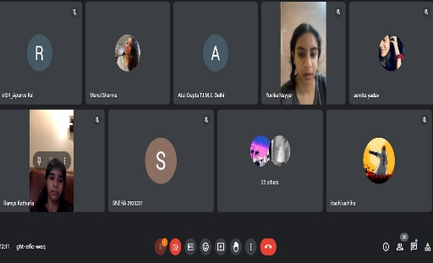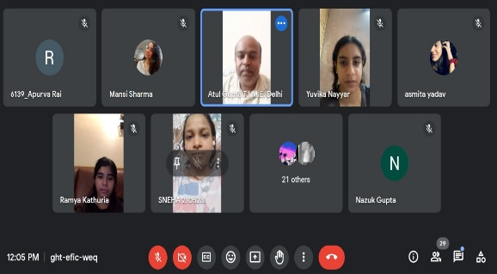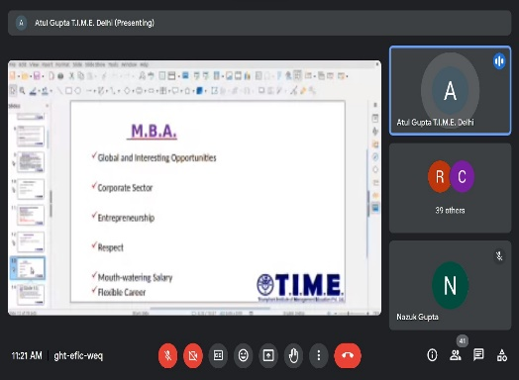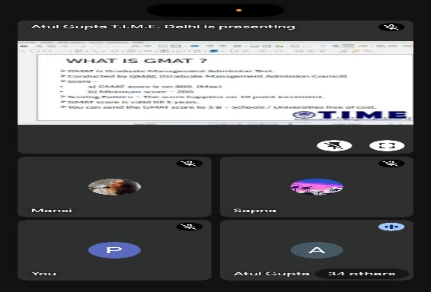
Email address | Name | Year
2105231@aditi.du.ac.in | Sneha | 3rd Year
bd6733431@gmail.com | Suhani Kumari | 1st Year
raiapurva14@gmail.com | Apurva rai | 3rd Year
Anshika2005v@gmail.com | Anshika verma | 2nd Year
ananyawadhwa03@gmail.com | Ananya | 3rd Year
vanyasindwani.du.ac@gmail.com | Vanya Sindwani | 3rd Year
8899deepali@gmail.com | Deepanjali | 2nd Year
mansisharma22012003@gmail.com | Mansi Sharma | 3rd Year
anu30piyush01@gmail.com | Anushka | 3rd Year
nazukgupta017@gmail.com | Nazuk Gupta | 2nd Year
sapnasiradhana129@gmail.com | Sapna | 2nd Year
tomarchelsiya@gmail.com | Chelsiya Tomar | 1st Year
nanshijangra16@gmail.com | Nanshi | 1st Year
chhavinandwani@gmail.com | Chhavi nandwani | 2nd Year
saniyash.204@gmail.com | saniya sharma | 2nd Year
parulyrkk@gmail.com | Parul | 3rd Year
muskankumari8056@gmail.com | Muskan Kumari | 1st Year
gargkashish101@gmail.com | Kashish garg | 3rd Year
roshni4847@gmail.com | Roshni kumari | 1st Year
gaursomya399@gmail.com | Somya Gaur | 2nd Year
Mehakgarg603@gmail.com | Mehak Garg | 3rd Year
uditajain47@gmail.com | Udita Jain | 2nd Year
ds1100400@gmail.com | Deepika Sharma | 1st Year
sehrawatnancy8@gmail.com | Nancy | 2nd Year
yuvikanayyar@gmail.com | Yuvika Nayyar | 2nd Year
singhchulbul869@gmail.com | Vartika Singh | 1st Year
sameforsam17@gmail.com | Shambhavi Singh | 3rd Year
monikasen.145@gmail.com | Monika sen | 2nd Year
parasharkhushi05@gmail.com | Khushi | 3rd Year
aakirtipandey81@gmail.com | Aakriti Pandey | 1st Year
bhardwajmohini17@gmail.com | Mohini bhardwaj | 2nd Year
muskantehlan45@gmail.com | Muskan | 2nd Year
manayalalwani089@gmail.com | MANYA LALWANI | 2nd Year
snehuu223344@gmail.com | Sneha Sharma | 2nd Year
kumaridipinti26@gmail.com | Dipinti Kumari | 2nd Year
guru65241@gmail.com | Sushmita Guru | 2nd Year
sg939044@gmail.con | Jyoti gupta | 3rd Year
singhmuskan7805@gmail.com | Muskan singh | 2nd Year
karanaishwarya3ka@gmail.com | AISHWARYA KARAN | 2nd Year

12. Name of the event- Internship and job fair
Department /committee– Internship & Placement Committee
Date – 15th April 2024

The "Internship & Job Fair’24" aimed to provide students with opportunities to connect with reputed companies and explore internship and job prospects. The event was conducted in an online mode and witnessed enthusiastic participation from 86 students across various disciplines.
The event was inaugurated by Prof. Mamta Sharma, Principal of Aditi Mahavidyalaya, who emphasized the importance of career fairs in bridging the gap between academia and industry. Prof. Priya Kanwar, Convenor of the Internship and Placement Committee, shared her vision for empowering students with career-oriented opportunities.
The Job Fair featured multiple companies from diverse sectors offering internships and full-time positions. Over 40+ companies participated, providing roles in fields such as marketing, finance, human resources, IT, and more. On the day of the Job Fair, registrations were done, and students were shortlisted for interviews by the participating companies. This process allowed students to showcase their skills and secure opportunities with reputed organizations.
The event was coordinated by Mansi Sharma (Student Coordinator) and Vanya Sindwani (Co-Coordinator), who ensured smooth management of the event. The companies presented their profiles, job descriptions, and recruitment processes, followed by interactive Q&A sessions with students. The event was highly engaging, with students actively participating and gaining insights into various career paths.
The Job Fair concluded with a vote of thanks delivered by Ms. Ramya Kathuria, Secretary of UTTHAAN, who expressed gratitude to all the participating companies, faculty members, and students for making the event a success. She highlighted the importance of such events in shaping the careers of students and fostering strong connections between academia and industry.
Overall, the "Internship & Job Fair’24" was a resounding success, empowering students to take the next step in their professional journeys and providing them with a platform to secure meaningful career opportunities.
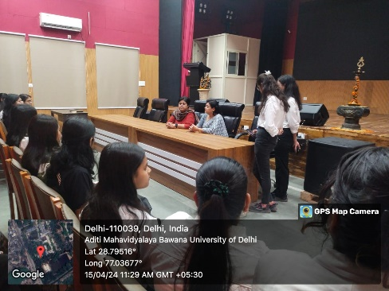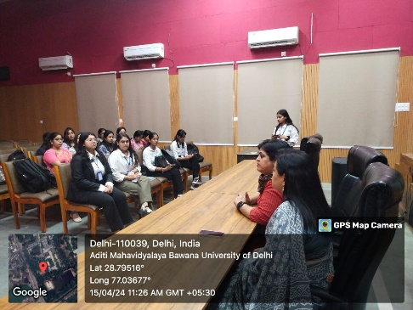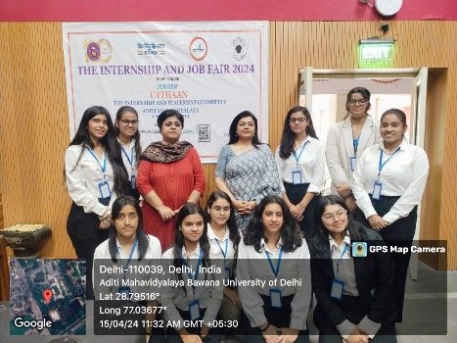

Email Address | NAME | YEAR
nishitanayal1@gmail.com | Nishita nayal | 3
nagpalmonisha3@gmail.com | Monisha Nagpal | 3
karanaishwarya3ka@gmail.com | AISHWARYA KARAN | 2
kratikaj19@gmail.com | Kratika jain | 2
dixitishika70@gmail.com | Ishika | 3
chotuyadav0905@gmail.com | Ritu yadav | 3
urvashikaushik240@gmail.com | Urvashi | 3
sachankhushi0@gmail.com | Khushi Sachan | 3
shiwanikum2002@gmail.com | Shiwani kumari | 3
sudiptitomar@gmail.com | Sudipti tomar | 3
snehuu223344@gmail.com | Sneha Sharma | 2
sakshijha44895@gmail.com | Sakshi Jha | 3
sakshijha44895@gmail.com | Sakshi Jha | 3
shakyapavitrigmai@gmail.com | Pavitri Rani | 3
nagmanigar502@gmail.com | Nagma nigar | 3
shubhikaushik30@gmail.com | Shubhi Kaushik | 2
khushitiwari2904@gmail.com | Khushi Tiwari | 2
deepprabhkaur09@gmail.com | Deep prabh kaur | 2
sehrawatnancy8@gmail.com | Nancy | 2
patwal.sonalika@gmail.com | Sonalika patwal | 3
prachi.piya308@gmail.com | Prachi | 2
komalkumari8543310@gmail.com | Komal Kumari | 1
pranjaliprans@gmail.com | Pranjali | 2
mahipriya0003@gmail.com | Mahi Priya | 4
kg780599@gmail.com | Komal Kumari Gupta | 3
taniyasachan03ts@gmail.com | Taniya Sachan | 2
bhagatpankhuri362@gmail.com | Pankhuri | 3
deepprabhkaur09@gmail.com | Deep prabh kaur | 2
ram72shiva@gmail.com | Kajal | 3
kumaridipinti26@gmail.com | Dipinti Kumari | 2
bhardwajdevansh20@gmail.com | Divya | 3
nirmalaGoswami0200@gmail.com | Nirmala Goswami | 2
gautamcheshta9@gmail.com | Cheshta gautam | 3
shrigupta0715@gmail.com | Shreya Garg | 3
kannusinghrajput719@gmail.com | Kannu | 3
muskaanbedi0607@gmail.com | Muskaan bedi | 3
raiakshita22@gmail.com | Akshita kumari | 3
mittalmansi593@gmail.com | Mansi | 3
parulyrkk@gmail.com | Parul | 3
krishnaverma3787@gmail.com | Krishna | 3
barsharanee1203@gmail.com | Barsharanee Rout | 2
shivanipathak998@gmail.com | Shivani Pathak | 3
Anshika2005v@gmail.com | Anshika verma | 2
shalinisrksharma@gmail.com | Shalini sharma | 3
khyatikaushik03@gmail.com | Khyati | 2
1607radhika@gmail.com | Radhika | 2
anushkag244241@gmail.com | Anushka Gupta | 1
somya057sharma@gmail.com | Somya Sharma | 3
saniyash.204@gmail.com | Saniya Sharma | 2
sainishalu429@gmail.com | Shalu saini | 2
gargkashish101@gmail.com | Kashish garg | 3
debbarmareshmika12@gmail.com | Reshmika Debbarma | 3
shafaqayaz2004@gmail.com | Shafaq Ayaz | 3
nidhiaggarwal377@gamil.com | Nidhi Aggarwal | 3
ananya44698@gmail.com | Ananya | 3
ritikabera8839@gmail.com | Ritika bera | 3
aroracharu2107@gmail.com | Charu Arora | 3
d.somani2004@gmail.com | Disha Somani | 3
chulbulsharma61@gmail.com | Divya Sharma | 3
mannatchawla57@gmail.com | Mannat Chawla | 3
gulati.garima123@gmail.com | Garima Gulati | 3
 | Shreya jain | 3
aakanshadata2015@gmail.com | Aakansha Data | 3
preetikumari8359@gmail.com | Preeti Kumari | 3
mansisharma22012003@gmail.com | MANSI SHARMA | 3
khushbugupta90155@gmail.com | Khushbu | 3
iampriyanka2203@gmail.com | Priyanka Sharma | 2
Upasnasharma2003@gmail.com | Premlata Sharma | 3
surbhi892003@gmail.com | surbhi sharma | 3
vaishnavimishra1630@gmail.com | Vaishanavi Kumari | 2
yeahmevarsha@gmail.com | Varsha Kumari | 3
singhjyoti4108@gmail.com | Jyoti Paswan | 2
kirtikasehrawat5@gmail.com | Kirtika | 2
singhjyoti4108@gmail.com | Jyoti | 2
kg20170122209@gmail.com | Karishma Gupta | 3
rashmimahoriya@gmail.com | Rashmi | 3
anjali876333304@gmail.com | Anjali | 2
yashikasharma1021@gmail.com | Yashika Sharma | 3
rashmitiwari0190@gmail.com | rashmi tiwari | 3
deep1719shikha@gmail.com | DEEPSHIKHA | 2
mehaksingh3000@gmail.com | Mehak | 3
khushidubey2511@gmail.com | Khushi | 2
khushbukumari7271@gmail.com | Khushbu Kumari | 2
arorachetna978@gmail.com | CHETNA ARORA | 3
nagarharshita688@gmail.com | Harshita Nagar | 2

13. NAME- Webinar on How to Prepare for Competitive Exams after Graduation
COMMITTEE/ DEPARTMENT- HDFE
DATE-21.4.24
Webinar on How to Prepare for Competitive Exams after Graduation with resource person Dr Santosh Yadav, Assistant Professor, Aditi Mahavidyalaya Dated 21 April 24. Dr. Yadav, a seasoned educator and mentor, provided invaluable insights and strategies for graduates aspiring to excel in competitive examinations across various fields. The webinar commenced with Dr. Yadav's elucidation on the significance of competitive exams in shaping career trajectories. He emphasized the importance of meticulous planning, strategic preparation, and effective time management as foundational pillars for success in competitive examinations. Dr. Yadav navigated attendees through a comprehensive roadmap for exam preparation, encompassing a range of competitive exams including civil services, banking, management, and specialized professional courses. Drawing from his extensive experience, he outlined the distinctive features and examination patterns of each domain, guiding participants on the selection of suitable exams aligned with their career goals and strengths. Throughout the session, Dr. Yadav underscored the significance of building a robust study schedule tailored to individual learning styles and preferences. He elaborated on the importance of accessing high-quality study materials, leveraging technology-enabled learning platforms, and engaging in regular self-assessment to gauge progress and identify areas for improvement. Furthermore, Dr. Yadav delved into effective exam-taking strategies, including mastering time management techniques, developing strong analytical and problem-solving skills, and cultivating a positive mindset to navigate the challenges posed by competitive examinations with confidence and composure. The webinar fostered an interactive environment, allowing participants to seek clarifications, share experiences, and glean insights from Dr. Yadav's expertise.
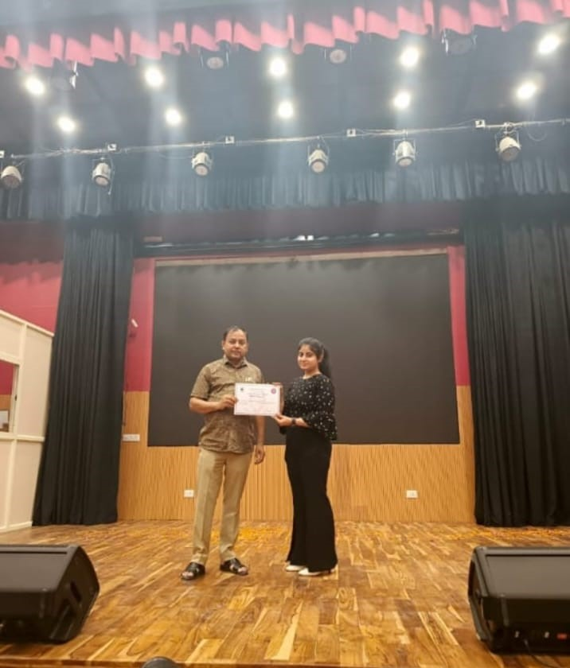

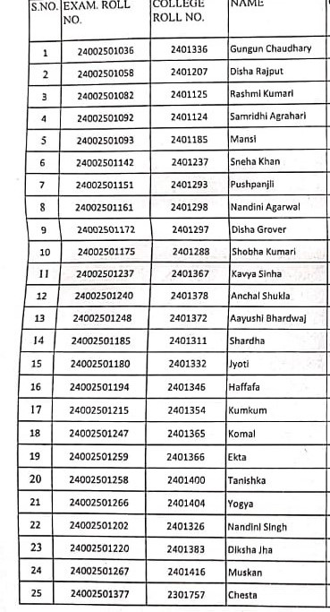

14. NAME- Career Opportunities in Special Education
DEPARTMENT- HDFE

Another talk was delivered by Mr Baldev Gulati, Assistant Prof. Social Work on 'Career Opportunities in Special Education'. He put forth many innovative arenas like career opportunities in Community Based Rehabilitation, Disability Tourism etc. He also mentioned that with the awareness and availability of opportunities for people with disabilities, many PwDs are turning into taxpayers and not the tax consumers.
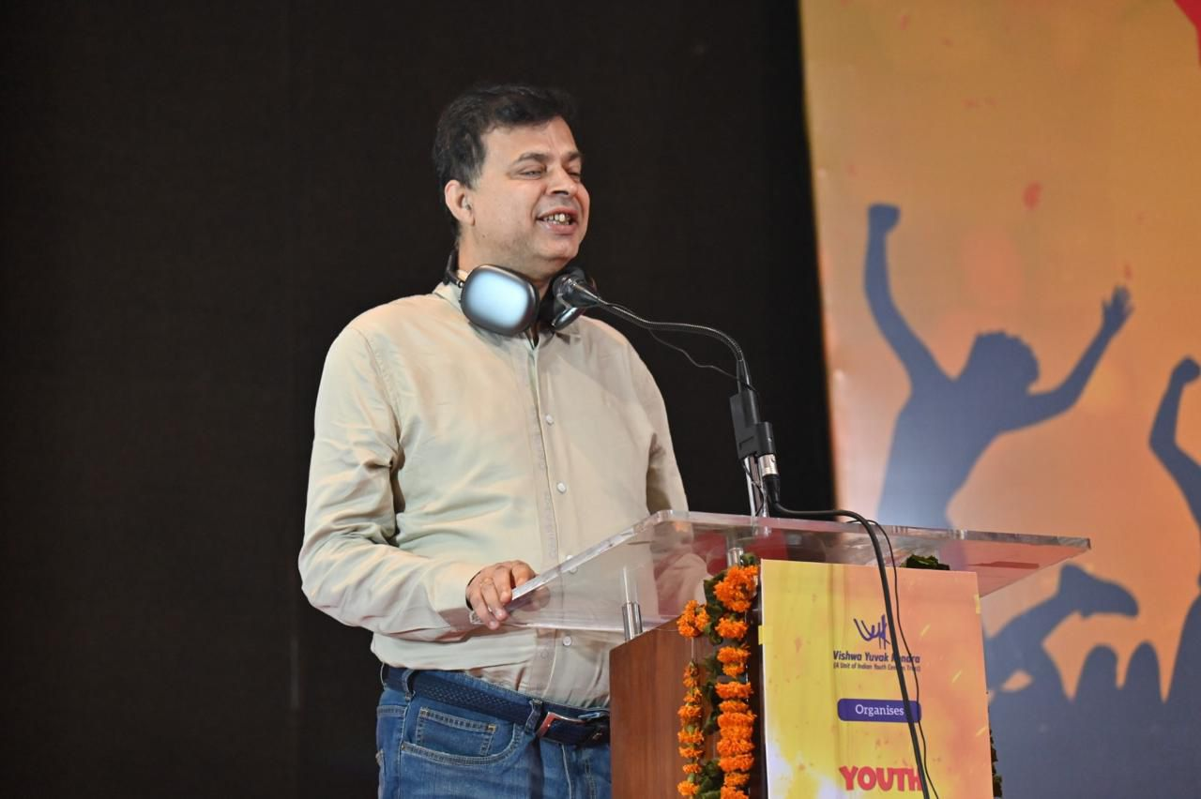

S NO | Name | SEMESTER | Department
1 | Sakshi | II | Social work
2 | Tamana Sharma | II | Social work
3 | Nidhi Yadav | II | Social work
4 | Sneha Rajpoot | II | Social work
5 | Jyoti Rawat | II | Social work
6 | Aarti | II | Social work
7 | Isha | II | Social work
8 | Tashu Vidlal | II | Social work
9 | Diya Chakraborty | II | Social work
10 | Riya | II | Social work
11 | Labli | II | Social work
12 | Aditi Rana | II | Social work
13 | Apeksha Agrahari | II | Social work
14 | Sakshi Kumari | II | Social work
15 | Charu | II | Social work
16 | Nyasha | II | Social work
17 | Vedita | II | Social work
18 | Khushi Kumari | II | Social work
19 | Rainbow Okram | II | Social work
20 | Himanshi | II | Social work
21 | Nancy | II | Social work
22 | Tanya | II | Social work
23 | Shikha Mathur | II | Social work
24 | Rimjhim | II | Social work
25 | Vandana Nagar | II | Social work
26 | Sama Praveen | II | Social work
27 | Diya Biswas | II | Social work
28 | Andrika | II | Social work
29 | Kanak Kohli | II | Social work
30 | Anjali Yadav | II | Social work
31 | Pooja | II | Social work
32 | Archana | II | Social work
33 | Alishba Ahmad | II | Social work
34 | Reet | II | Social work
35 | Priyanshi Jain | II | Social work
36 | Kanika | II | Social work
37 | Muskan Kumari | II | Social work
38 | Priyanshi Goswami | II | Social work
39 | Lekshmi Bijumon | II | Social work
40 | Anushka Sinha | II | Social work

